Science and Technology

Monday, 23 May 2022

11:58 PM

**Theory:**

* + Fundamental concepts.
  + Space, nuclear, defence, robotics, ICT, etc.

**Applications:**

* + Day to day life, socio-economic development, economic growth, national security, etc.
  + Scientific organizations (ISRO, DRDO, BARC, etc)

**Topics to be covered**

* + Space and astronomy
  + Defence technology
  + Nuclear power, Renewable energy
  + Information and Communication Technology
  + Biotechnology, nanotechnology, AI, robotics, block-chain, etc.
  + AR and VR - related aspects.

**Syllabus related aspects:**

* + S&T Developments.
  + Contribution of Eminent Indians in S&T: E.g.- S.N. Bose, Dr. Vikram Sarabhai, Dr. CV Raman, Homi Bhabha, APJ Abdul Kalam, M.S. Swaminathan, etc.
  + Indigenization of technology, IPR issues, and Developing New Technology.

## Science and Technology Development in India

* + **Ancient Times**
    - Legacy of the S and T from ancient times.
    - Town - Planning: Indus valley civilization.
    - Mathematics - Zero was founded, Arabic number, Decimal system, etc.
    - Astronomy - Contribution of Aryabhata, Bhaskara, etc.
    - Metallurgy- Mehrauli iron pillar, sculptures making.
    - Medicine - Ayurveda, Charak, Sushruta, etc.
    - Ancient learning centres: Travellers, etc.
    - Universities like Takshashila, Nalanda, Vikramshila, etc.

* + **Medieval Times**
    - Astronomy - Jantar Mantar at Jaipur, Delhi, Ujjain, Varanasi, and Mathura.
    - Medicine - Siddha, Ayurveda, etc.
    - Irrigation - Delhi Sultanate, Mughal.
    - Artillery - Cannon, weapons.

* + **Modern Times**
    - **Pre- Independence:**
      * The printing press, Railways, Telegram, Post, Archaeology, PWD, etc.
  + **Post- Independence:**
    - **Formative period(1950-70)**
      * Space, Nuclear, Defence, Agriculture, green revolution, etc.
      * Multi-purpose heavy industry
    - **Expansion period(1970-90)**
      * Biotechnology, Health, Earth Sciences, Computing, advanced computing, etc.
    - **Advanced period(1990-till present)**
      * Nano Technology, Robotics, LASER, etc.

### Achievements of ISRO:

* + Established in 1968
  + **Launch vehicle technology**
    - **a)Historical:**
      * **Satellite launch vehicle (SLV)**
      * **Augmented satellite launch vehicle(ASLV)**
    - **b)Operational:**
      * **Polar satellite launch vehicle(PSLV)**
      * **Geo-synchronous launch vehicle(GSLV)**
    - **c)Future**
      * **Reusable launch vehicle (RLV)**

* + **Satellites**
    - **i)INSAT (Indian National Satellite System)**
    - **ii)IRS**
    - **iii)IRNSS**
  + - **Space and Astronomy**

* + I)Chandrayan 1
  + ii)Chandrayan 2
  + Chandrayaan 3
  + iii)Mangalyan

* + **Future space missions:**
    - **ADITYA**
    - **Shukrayan (venus craft)**
      * 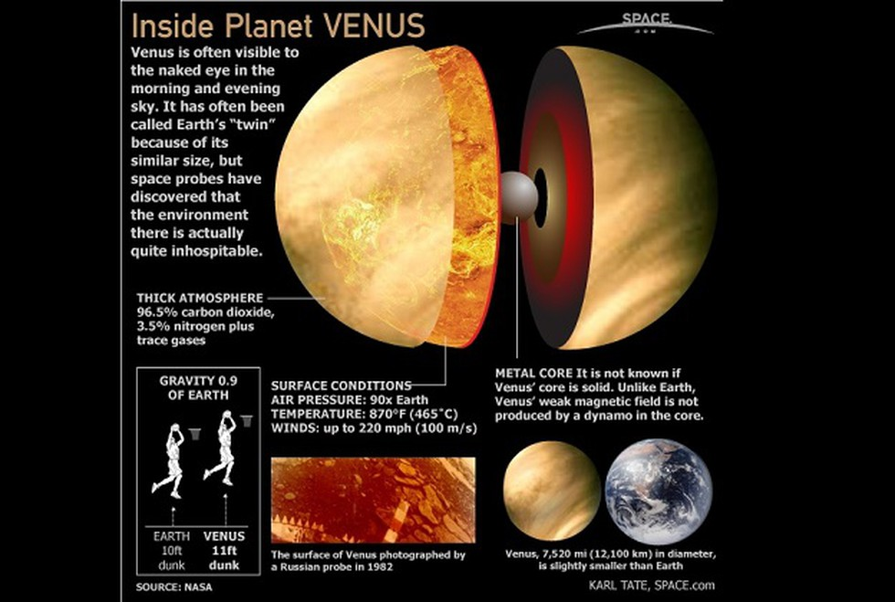
    - **Gaganyan**

### Achievements of DRDO:

* + **Missile technology:**
    - **i)Indigenous missile system**
      * Integrated guided missile program (IGMP)
      * 5 missiles: - **PANTA**
        + Prithvi - Surface to surface short range
        + Agni - surface to surface long range
        + Nag - 'fire and forget' anti tank missile
        + Trishul - short range surface to air
        + Akash - medium range surface to air
        + Astra Mk1 Missile - Beyond Visual Range Air to Air Missile (BVRAAM), range of 80-110 km

* + India and Russia collaborated:
    - Brahmos supersonic cruise missile
    - Submarine launch ballistic missile

* + **ii)Naval system**
    - Submarines
      * Project 75I scorpion class submarine
    - Warships
      * Destroyer
      * Frigates
    - Aircraft carriers
    - SONAR
    - Torpedo

* + **iii) Aeronautics and avionics**
    - LCA Tejas
    - Helicopter
    - Drones

* + **iv)Electronic warfare**
    - RADAR
    - Interception system

### Achievements of BARC

* + **1)Nuclear reactor:**
    - **i)Nuclear power**
      * Pressurize heavy water reactor(PHWR)
      * Fast breeder reactor(FBR)
      * AHWR(Advanced heavy water reactor) - 3rd stage is thorium reactor

* + **ii)Research reactor:**
    - Dhruv
    - Apsara
    - Purnima
    - Kamini

* + **2)Nuclear weapon**
    - Atom bomb
    - Hydrogen bomb

* + **3)Societal applications**
    - i)Nuclear medicines
    - ii)Nuclear agriculture

* + **4)Industrial application**
    - Detection of cracks

### Science and tech policies

* + **i)Scientific policy resolution 1958**
    - Basic and applied scientific research in-country
    - scientific manpower
    - retention of meritorious scientists
    - importance to space research, defence, etc.

* + **ii)technology policy statement 1983**
    - self-reliance in technology
    - mass production technology
    - production by masses
    - importance to food, agriculture, etc.

* + **iii)science and technology policy 2003**
    - advance technology policy
    - focus on advanced technology
    - lab to market approach
    - gender aspect in India

* + **iv)Science and tech innovation 2013**
    - Innovation ecosystem at all levels
    - Double scientific publication in 10 years
    - PPP in R&D
    - International collaboration

**Science and technology program:**

* + 1)Atal Innovation Mission(AIM)
  + 2)Innovation in science pursuit for inspired research (INSPIRE)
  + 3)MANAK
  + 4)Knowledge environment in research and nurturing (KIRAN)
  + 5)Impacting  Research and innovation (IMPRINT)

**Eminent Indian Scientists**

* + Founding fathers
    - Space - Dr. Vikram Sarabhai
    - Defence - Dr. Raja Rammanna
    - Nuclear- Dr. Homi Jehangir Bhabha
      * He gave 3 stages of the Atomic Energy Program with the development of different types of reactors and nuclear parks.
      * He also laid the foundation of TIFR, Mumbai, and BARC. He served as the first chairman of the Atomic Energy Commission under the Department of Atomic Energy.
    - Mathematics - S Ramanujan (Movie- The man who knew infinity)
    - Defence - Dr. APJ Abdul Kalam
    - Others: Dr. JC Bose (Physics and Botany)
      * Astrophysics - Dr. Meghnad Saha (Saha equation)
      * Dr. SN Bose (Bose statistics)
    - Agriculture - Dr. MS Swaminathan (Green Revolution)
    - M. Visveswaraya (dams)
    - Dr. CNR Rao - mainly in solid-state and structural chemistry.
    - Dr. Birbal Sahni - study the fossils plants
    - Noble Laureates - Dr. CV Raman (He studied life of star, particularly white dwarf star)
      * Dr. S Chandrasekhar
        + Chandrashekhar limit- 1.44 times mass of sun.
      * Dr. Hargovind Khurana- studied the genetic code.
      * Dr. Venkat Ramakrishnan- Structure and function of ribosomes
    - 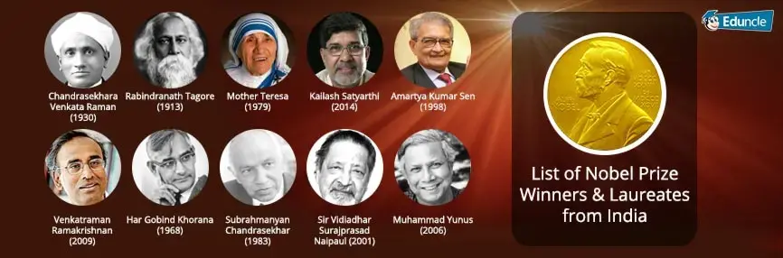

### Indigenization of technologies

* + Development of new technology within the country using its own resources to meet national needs.
  + Indigenization also refers to the modification of existing technologies which has been acquired through the “transfer of technology” (ToT) agreement signed with foreign countries (Reverse Engineering).
  + Examples :
    - Indigenous cryogenic engine used in the third stage of GSLV.
    - INS Arihant (Nuclear powered submarine) propelled by 45 MW.
    - Pressure water reactor (PWR) by BARC (Modified Technology of Russian submarine INS Chakra)

* + **Benefits**
    - Enhances R&D base in India
    - Reduces dependence on other countries for transfer of technology thereby it helps in self-reliance and minimize overflow of foreign exchange
    - Boost the manufacturing sector in the country which will increase employment in India.
    - It also helps in the development of expert scientific human resources.
    - Cost-effective technology. E.g.- Param Supercomputer
    - Creates market of Indian technologies. Small countries like Mauritius etc will buy our products.
    - Socio-economic development

* + **Problems/ challenges in Indigenization of technologies**

* + **At international level**
    - Geo-political situations can hinder the transfer of technology to India. E.g.- transfer of technology to India. E.g.- Transfer of advanced nuclear technology to India from Nuclear Suppliers Group (China’s opposition)
    - Nuclear Suppliers Group, Missile Technology Control Regime, Australia Group will control the trade of weapons.

* + **At national level**
    - Lack of indigenization policy
    - Lack of funding for indigenization
    - Lack of expert scientific manpower
    - Lack of manufacturing base in the country
    - Delay in approval for indigenization on project (bureaucratic hurdle)

* + **At organizational level**
    - Lack of encouragement to promote Indigenization within scientific organization
    - Lack of autonomy to take decisions by scientific organizations
    - Lack of skills and training
    - Attrition in scientific organization delays ongoing project
    - Lack of sufficient funds for a long time.

* + **Way Forward**
    - There shall be a National Level Indigenization Policy
    - Development of Manufacturing Capability
    - Sufficient funding to indigenization projects
    - Emphasis on Indigenization of technology by India in Transfer of Technology Agreement or deals with other countries
    - Atmanirbhar Bharat and Make in India programs to support Indigenization
    - International Collaborations

### Intellectual Property Rights

* + Products of the human mind, the fruits of human creativity and innovation.
    - E.g.- inventions, literary and artistic works, designs, Geographical Indications (Kanjivaram sarees), Trade secret.
    - Property can be divided into:
      * Tangible (physical form) - Land, house, car etc
      * Intangible (Intellectual form)- e.g.- Intellectual Property

* + **Significance of IPR**
    - Promotes creativity and innovation in society
    - Generation of Intellectual Property Wealth. E.g.- Drugs, vaccines, Machineries etc.
    - Bundle of rights to IPR holders namely ownership right, economic right, moral right etc. (Reputation of IPR Holder)
    - Exclusive rights of use by IPR holder and one needs permission from IPR holder for use.
    - Legal right to take actions against infringement of IPR.

* + **Patent (invention)**
    - i)Patent is granted for inventions which can be product or process
    - ii)Patent is granted based on National law i.e. in India patent is covered under Indian patent Act 1970
    - iii)Patentability provisions are covered under respective national law

* + **What is an invention?**
    - A product or a process that provides, in general, a new way of doing something, or offers a new technical solution to a problem.

* + **What is a patent?**
    - An exclusive right, that allows to prevent or stop others from commercially exploiting the patented invention granted by a State or by a regional office acting for several States applicable in the country or region in which the patent has been filed and granted, in accordance with the law of that country or region for a limited period, generally 20 years from the filing date of the application.
    - There are conditions of patentability

* + **Three principal requirements for inventions to be protected (Conditions of patentability)**
    - **Novelty:**
      * New characteristic not known in the body of existing knowledge (prior art) in its technical field Inventive step
    - **Non-obviousness**:
      * Cannot be deduced by a person with average knowledge in its technical field industrial application
    - **Utility:**
      * The invention must be of practical use or capable of some kind of industrial application plus disclosure of the invention
    - If these conditions are not met: A patent should not be granted.
      * If this is discovered later, patents can be revoked or invalidated.

* + **Patent issues:**
    - **1) Patenting of traditional knowledge(TK)**
      * E.g.: Turmeric patent
      * Test based on 3 conditions of patentability:
        + i)Fails on novelty as prior art already exists
        + ii)Fails on non-obviousness that is inventiveness
        + iii)Though passes on the usefulness

* + **2)Generic drugs /medicine**
    - Drugs/medicine manufactured based on formulates of expired drug
    - A cheap or low-cost drug manufactured in bulk

* + **3)Ever-greening**
    - Re-patenting the same medicine with little changes/modifications after 20 years
    - Example:
      * Novartis ‘Glivec ‘ case

* + **Compulsory licensing(CL):**
    - CL is given by the Indian patent office to manufacturing to selling a patented product after 3 years on 3 grounds
      * i)Reasonable needs of Indian society not satisfied
      * ii)Patent is not working in India that is patent on the product is existing outside India
      * iii)Essential and Not affordable
    - Section 84 of the Indian patent act 1970 provide this CL provision
      * Example: Nexavar drug: the first instance of CL given to Nexavar to NATCO pharma
      * It is given in exceptional cases, (generic drugs for which india is leader in exports, comprises of drugs on which patents have already expired)

* + **Trademark:**
    - Registered under Trademark Act, 1999
    - A trademark is a sign capable of being represented graphically Which is capable of distinguishing goods or services of one undertaking from those of other undertakings.
    - It is a sign capable of being represented graphically
    - Example:
      * Logo
      * Which is capable of distinguishing goods or services one undertaking from those of other undertakings

* + **What does a trademark do?**
    - The proprietor of a registered trademark has exclusive rights in the trademark which are infringed by the use of the trademark in the given territory without his consent

* + **Capacity to distinguish :**
    - The sign must be capable of distinguishing the goods or services of one undertaking from the goods or services of another A failure to comply with this requirement constitutes an absolute ground for refusal of registration

* + **Categories of absolute grounds**
    - Exclusion from registrability of signs that are : -
      * Non-distinctive (ex: single letters or numerals) –
      * Descriptive (ex: BABY DRY for nappies)
      * Generic (ex: aspirin, escalator, sellotape, hoover)
      * Contrary to public policy or morality
      * Likely to deceive the public
      * Prohibited by law
      * Made in bad faith

* + **Trademark infringement**
    - The proprietor of a registered trademark has exclusive rights in the trademark which are infringed by the use of the trademark in the given territory without his consent
    - No requirement of knowledge or intention on the part of the defendant.
    - Liability is strict No need to demonstrate damage

* + **Invalidity and revocation**
    - A trademark may be declared invalid if it was registered in breach of one of the absolute or relative grounds for refusal
    - A trademark may be revoked
      * For non-use
      * For suspension of use
      * If the trademark has become the “common name in the trade” (generic)
      * If the trademark has been used in a way so that it is liable to mislead the public (deceptive)
      * 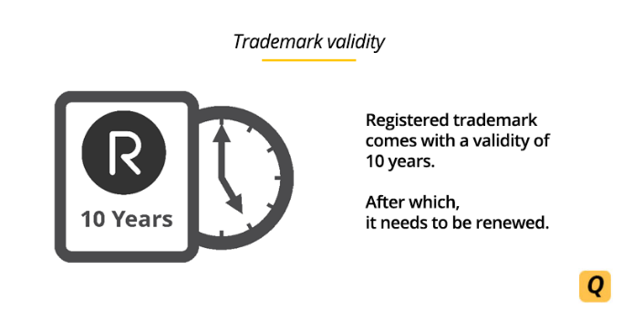

* + **Trade Secret:**
    - Secret
    - Commercial value
    - Subject to reasonable steps to keep it secret

* + **Why Trade Secret**?
    - No procedural formalities Unlimited period of time
    - जब तक भांडा ना फूटे

* + **Geographical Indication (GI)**

* + **What are Geographical Indications?**
    - A sign used on goods that have a specific geographical origin (the name of the place of origin of the goods and/or symbols without literally naming its place of origin).
    - Possess qualities, reputation or characteristics that are essentially attributable to that place of origin.
    - In short,  to be distinct due to geographical location.

* + **Recognition of intellectual property is based on the application of origin of goods and services**
    - Example:
      * Nilgiri tea, Darjeeling tea
      * Mysore Pak
      * Mysore silk
      * Madhubani painting
      * Tirupati laddoo
      * Alphonso mango etc.

* + **Collective right**
    - Enjoyed by all of that particular area
  + A registered GI shall be valid for 10 years and can be renewed on payment of renewal fee.

* + **Industrial designs:**
    - The ornamental or aesthetic aspect of an article
    - 3-D shape or surface of an article
    - 2-D patterns, lines, or colour

* + **Why protect industrial designs?**
    - A design is what makes a product attractive and appealing contributes to commercial value and marketability promotes fair competition and honest trade practices help economic development, by encouraging creativity

* + **How can industrial designs be protected?**
    - In most countries, must be registered in order to be protected unregistered design
    - Must be “new” or “original” no identical or very similar design is known to have existed before

* + **Copyright**
    - i)Rights over literary and artistic and dramatic works etc.
    - ii)Related rights to copyrights
    - iii)Photographs are copyrighted
    - iv)Software programs are copyrighted
    - v)There are a bundle of rights(Economic rights and moral rights)
    - The exception to Vth:
      * Fair use(academic and teaching, references)

* + Unlike Patent, copyright does not specifically require registration. Copyright does not mandatorily require registration but registration proves originality.

* + **Issues:**
    - Plagiarism
    - Piracy of books, movies, videos, etc.
    - There are different copyrights:
    - For books: Life of author plus Min 50 year after the death
    - For movies: 50 years

* + **Conditions for protection**
    - Arises automatically:
      * Even if you have not registered for copyright the moment an original work is created you have copyright
    - ii)No formalities

* + **Idea/Expression**
    - Ideas are not protectable in themselves, but the expressions of such ideas are protectable

**Copyright does not protect:**

* + ideas, procedures, processes, systems, methods of operation, concepts, etc.
  + It only protects the way ideas are expressed in a particular work What can be protected: the characteristics by which the author has made the theme personal

* + **Why?**
    - Would it be productive, efficient, fair, or morally justifiable to give exclusive rights to the first person to write about an idea?

* + **Originality**
    - Not necessarily novelty ingenuity inventiveness aesthetic merit

* + **Violation/ Infringement:**
    - Some myths we can copy as long as we don’t sell
    - Any copying is unlawful anyone who without permission carries out one of the reserved acts
  + 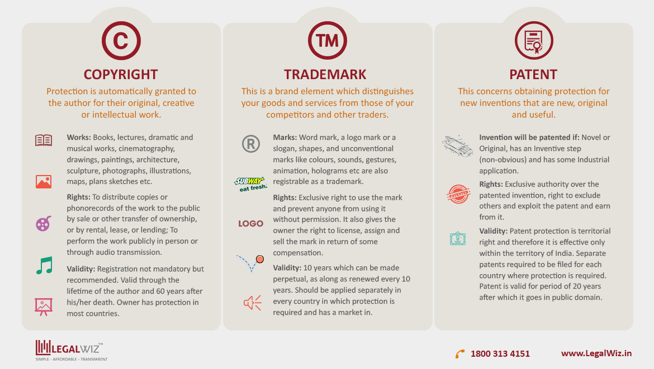

## Blueprint for the class discussion

* + Outer Space
  + Launch Vehicles
  + Concept of the Orbit
  + Lagaragiaon Points
  + Satellites

* + **Outer Space**
    - Earth and Atmospheric segregation in troposphere, stratosphere, Mesosphere, and Exosphere.
    - Karman Line defines Outer space. It is located 100 km above the surface of the Earth and is considered the starting point of outer space.
      * 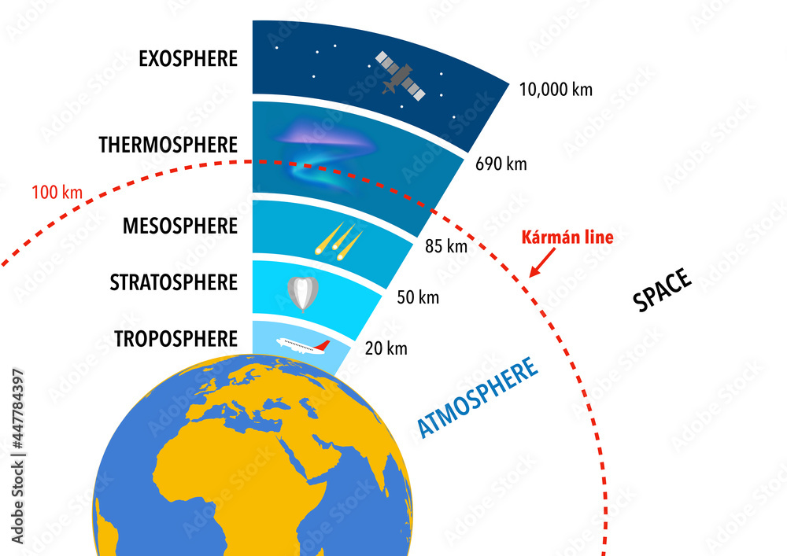

* + There is an international treaty called Outer Space Treaty, 1967, an intergovernmental treaty, determines space activities in outer space including the moon, and other celestial bodies.

* + **UNOOSA**
    - The United Nations Office for Outer Space Affairs (UNOOSA) works to help all countries, especially developing countries, access and leverage the benefits of space to accelerate sustainable development.
    - It works toward this goal through a variety of activities that cover all aspects related to space, from space law to space applications.
    - **Global Commons : Examples:** Space, internet, oceans, Air, Antarctic, and the Arctic, etc.

* + **Outer Space Treaty, 1967**
    - Defines that outer space is the common heritage of mankind. There is no territorial and sovereignty claim by any nation. Outer space belongs to humanity.
    - Outer space should be used for peaceful purposes only.
    - Outer space should be prohibited from weaponization.
    - Outer space should not be used for weapons of mass destruction (WOMD).
    - Outer space shall not be contaminated.
    - Astronauts are the ambassadors of mankind and they should always work for the welfare of mankind. Any astronauts coming from any country will always work for humankind.

* + **Launch Vehicle**
    - A launch vehicle or a rocket is a type of propulsion system to launch a spacecraft, space probe, and crew module into designated orbits in outer space.
    - There are various types of launch vehicles designed and developed by space agencies worldwide.
    - We can broadly classify these vehicles into two categories: Expandable Launch Vehicle (ELV) and Reusable Launch Vehicle (RLV).
      * The examples of ELV are the GSLV, and PSLV, Vostok, Long March, Dragon (Space X)
      * The example of RLV are Discovery, Challengers, Endeavor, Atlantis, Colombia, Soyuz (Roskosmos), Shenzhou (CNAS), Falcon (Space X)
    - A launch vehicle consists of the Engine (Propulsion system), fuel, and Payload.

* + **Engine (Propulsion system)**
    - A launch vehicle engine uses propellant (fuel) which is burnt using the oxidizer to generate high thrust exhaust.
    - There are various types of propulsion engines. These are Non-Air Breathing System, Air Breathing Air System, and Cryogenic engine
    - A non-Air Breathing System uses an oxidizer to burn the fuel.
    - Air Breathing Air System uses oxygen gas from the atmospheric air to burn the fuel. RAMJET and SCRAMJET are examples of these types of systems.
      * SCRAMJET is a special type of RAMJET. It takes in atmospheric air with a high velocity of 2 mac to 5 mac by a nozzle. To burn the fuel to generate exhaust gases producing hypersonic speed.
        + **This technology has the following benefits**

It saves money in terms of the manufacturing of the oxidizer

It helps in reducing the overall weight of the rocket thereby it can launch a higher payload.

It can provide hypersonic speed.

**Cryogenic Engine**

* + It is a propulsion technology that stores liquefied hydrogen at 20 Kelvin (-253° C) temperature and liquefied oxygen at 90 Kelvin and burns to produce high thrust.

* + **Benefits:**
    - **Sustainability:** Availability of fuel for a long time.
      * It is an eco-friendly technology.
      * It has high storage of the fuel in liquefied form
      * It provides high thrust.
      * Challenges with technology
      * High combustible nature of the hydrogen
      * Maintenance of extremely low temperature.
      * It is an expensive technology.

* + **Fuel (Propellant)**
    - It could be of two types that is solid fuel and liquid fuel.

* + **Solid Fuel:**
    - Hydroxy Tetra Poly Butadiene (HTPB). In PSLV and GSLV we use this fuel. It has advantages such as it is easy to store and transport. No risk of leakage and inflammation.
    - It has disadvantages such as heavy and bulkiness. It also has non-uniform burning.

* + **Liquid Fuel**
    - (UDMH + H2O4) Unsymmetric Dimethyl Hydrazine.
    - **Benefits:** It occupies less space and is lightweight. It helps in uniform burning. It is easy to control the switch on and off process.
    - **Disadvantages**: It is highly inflammable, thus it needs a special type of storage. It is corrosive in nature. It has a special container to store such fuel.

* + **Payload**
    - Which is launched by the Launch Vehicle. It could be satellites, Crew Module, spacecraft itself, Astronomical telescope, etc.

* + **SSLV** 
    - Small Satellite Launch Vehicle - ideal for the on-demand, quick turn-around launch of small satellites.
    - All-solid three-stage vehicle
    - Payload capability **of 500 kg satellite mass into 500 km Low Earth Orbit (LEO) or 300 kg to Sun-Synchronous Polar Orbit.**
    - SSLV has a low turnaround time and can be assembled within a fortnight
    - 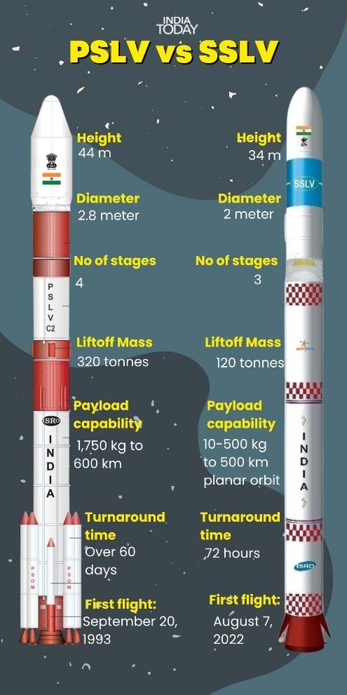

* + **PSLV and GSLV**

|  |  |
| --- | --- |
| **Polar Satellite Launch Vehicle (PSLV)** | **Geo Synchronous Launch Vehicle (GSLV)** |
| It is four stages LV which uses solid fuel in the first and third stage and Liquid fuel in 2nd and last stage. | It is the three-stage LV with first stage solid, second-stage liquid, and last upper third stage is the cryogenic engine. |
| It is primarily designed to launch remote sensing but it can also launch communication satellites up to 350 Kg class satellite into a geosynchronous transfer orbit. | It has been designed to launch heavier communication satellites of two tons to 4 tons into a geosynchronous transfer orbit. |
| It has three configurations, that is core alone (Solid-Liquid-Solid-Liquid and it does not have satrap motors). Standard Configuration (Booster in the first stage, Strap on motors, S_L_S_L) and Extra Large Configuration (The first stage has six strap-on motors with more fuel, S_L_S_L). With extra-large, we can launch up to 1700 Kg payload. Extra Large LV was first used in Chandrayaan Mission under PSLV C11 in 2008, In Mangalyaan we used extra large PSLV C25, | It has also three configurations that are GSLV Mk I (Up to 2000 Kg satellite, S_L_C), GSLV Mk II (from 2 tons to 3 tons, it has four boosters at the first stage S_L_C), GSLV Mk III (Up to 4 tons in GTO, 10,000 Kg payload in LEO, it uses two heavy solid boosters, then will have the liquid and cryogenic engine in the last stage.    Boosters are also like engines to give additional thrust.  Chandrayaan 2 we used GSLV Mk II, |

* + **Orbit**
    - An orbit is an imaginary path by a celestial body or artificial or man-made satellite.
    - Orbital speed : The speed/velocity at which the satellite moves in its orbit.
    - Newton’s Universal Law of Gravitation: Fg = GMm/R2 (square)
    - **Centripetal Force:** Whenever a body moves in a circular path, a force acts towards the centre.
      * Fc= MV2 Square)/R
        + Centripetal force for the satellite is provided by gravity.
      * MV2/R = GMm/R2 (Square)
      * V2= GM/R
      * **Vorbit = √GM/R**
        + The orbital speed of the satellite does not depend upon the mass of the satellite but depends on the distance orbit from the earth. When an orbit is near to the earth, a satellite moves fast with higher orbital velocity.

* + **Classification of the Orbits**
    - Classification based on the shape of the Orbit. It could be elliptical and circular orbit. Apogee (farthest point), perigee (Nearest point). Distance of the satellite change. In a circular orbit, the distance will remain constant, thus the orbital speed as well. Geostationary Orbit has a circular orbit.
    - On the basis of the revolution of Satellites around the earth: It could be of two types are Geo Synchronous Orbit and Sun Synchronous Orbit. The movement of the satellite is synchronized with respect to the rotation of the earth. It is an elliptical orbit and it will be in the equatorial plane.

* + **Sun-Synchronous**: The satellite will be on the polar plane. It will be always the Sun Synchronous Polar Orbit. Remote sensing satellites follow this orbital path. The movement of the satellite is synchronized with respect to the revolution of the earth around the sun. It is a circular orbit in the polar plane.

* + **Geostationary orbit:** It is a circular orbit. It lies at the equatorial orbit. It is used by the communication satellites. The distance of the orbit is 35780 Km. It is called stationary because the satellite's position remains fixed with respect to any position on the earth. The orbital speed of the satellite matches the rotational speed of the earth. Direction should be west to east. The orbital time is 24 hours.

* + **GSLV MKIII significance**
    - To launch heavier satellites.
    - Launching multiple nano satellites.
    - Offer services of launching vehicle for other countries and companies and hence increase share in commercial global market e.g. **ANTRIX** is commercial company of ISRO and in past India launched more than 100 foreign satellites etc. recently India created New space India limited.
    - It is useful for Human space flight (GAGAN YAAN mission).
    - Chandrayaan Mission-2 launched was GSLV Mk-III.
      * In future GSLV Mk-III will be used for launching CHANDRAYAAN MISSION-3.

**Challenges of RLV**

* + It is veryadvanced technology development and hence required heavy funding for R&D. Only three countries in the world have this technology USA, Russia and China.
  + Infrastructure development such as launch pad, landing sites of winged aircraft, training of human astronauts.
  + Requires a long runway of 10-15 km on coast which are vulnerable to disasters such as cyclone etc .
  + India going to face competition from private Space entities such as SpaceX

* + **Classification of Orbits**
    - **Based on height of the orbit.**

**Low earth orbit (LEO)**

* + Any orbit up to 2000 km from the surface of the earth
  + **Application of LEO.**
    - **Earth observation satellites**. It is also referred as Remote sensing.
      * It does image of forest, agriculture, sea etc Example CARTOSAT-3.
      * Cartosat was launched by PSLV C-37 and altitude 509kms.
      * Application Of Cartosat-3, — urban planning, rural resource and infra development, coastal land use.

* + **Application in Meteorology** example SCATSAT-1, OceanSAT etc
    - **Astronomical satellites and Astronomical telescopes example**Hubble space telescope of NASA in 1990 and ASTROSAT by ISRO in 2015 and its located at 650km altitude.

* + **Space station**are built in the Low earth Orbit. Currently in Use is international space station (ISS). Its operated and used by NASA(USA), ROSCOSMOS(Russia), ESA(EU), JAXA(JAPAN),CSA(CANADA).
    - China is developing its own space station and it is named as TIANGONG.

* + **Application of ISS-**
    - Understand impact of low gravity on human beings
    - For conducting microgravity research such as biological experiments.
    - Earth observation, observation of pollution, climate etc
    - Act as a space terminal for placing space modules and for space voyage.
    - Repair of satellites which are in LEO or astronomical telescope.
    - Can be used for refuelling.
    - Astronomical observation such as comets, meteorites
    - Space tourism.
    - Surveillance purpose and info gathering.
    - Military application.
    - India going to launch GAGANYAAN Mission for conducting the space experiments such as microgravity experiments, astronomical observation.

**Medium Earth Orbit**

* + From 2000 km to 35,786 km altitude from the surface of earth.

* + **Application of MEO.**
    - **Earth Observation (remote sensing)**
    - **Astronomical observatory such as satellite or telescope.**
      * **Example**Chandra X-ray observatory is US satellite designed for high resolution images of celestial X-ray sources. its in operation since 1999 and named after Subrahmanyam Chandrashekhar. It’s in elliptical orbit (it’s in MEO with perigee (closest position to earth) 10000 km and apogee 140,000 km (farthest position from earth).
    - **Navigational satellites - Example GPS.**
      * Navigational means movements such as
      * Coordinates such as longitude, latitude, depth altitude etc
      * Help to locate a moving object in 3-dimensional space (air, land, water) or stationary object on the earth by GPS satellites (Positioning )
      * It has both civilian and military applications

* + **Civilian application**
    - Such as bank, hotel, any monument, Movement of vehicle such as public transport railways, OLA, UBER cab service.
  + **Military application.**
    - Tracking an enemy target such as troops, aircraft etc
    - Guidance system of missile.

* + **GPS system Worldwide**
    - USA - NAVSTAR (navigational satellite for ranging) also known as GPS.
    - Russia **-**GLONASS (global navigation satellite system)
    - Europe - Galileo.
    - China- Beidou I-China has first built regional GPS.
      * Beidou-II->Global system . also known as Compass navigation system.
    - India - IRNSS(Indian regional navigational satellite  System ) also known as NAVIC ( navigation with Indian constellation)

**Geostationary orbit.**

* + Used for communication satellites and it is located in MEO at a height of 35784 km

**High Earth Orbit**

* + Any orbit which lies above 36000 km height.

* + **Application**
    - **Astronomical**Observatory and example Kepler space telescope of NASA.
    - **Kepler**helped in discovering the many solar systems and earth like planets in milky way in Goldilocks zone.
    - **GOLDILOCK zone –**means earth is located from sun where temperature is not high and not very low and hence its habitable.
      * NASA will be placing James Webb telescope in HEO

* + **Transfer Orbit**
    - Temporary orbit is used for manoeuvring a satellite to its designated orbit.
    - They are in an elliptical orbit.
    - Satellite is built with motors: E.g. LAM motors: Liquid Apogee Motors.
    - The motor is added to the satellite to give thrust for manoeuvring.
    - Newton Engine is an example of the same.

* + **Benefits of transfer orbit:**
    - It saves the fuel of the launch vehicle/rocket which drops the satellite to the perigee of the transfer orbit.
    - By using transfer orbit, it provides control, which can be brought to the desired orbit.
    - Control is possible by using ‘transfer orbit’, ISRO uses this kind of temporary orbit.
    - It takes 10 to 12 days to come to Geostationary orbit.

* + **Hohmann Transfer Orbit**
    - Hohmann transfer orbit is a type of transfer orbit.
    - It is an elliptical orbit, used to transfer a spacecraft from a circular orbit to a higher circular orbit, without spending a high amount of fuel on the satellite/spacecraft.
    - 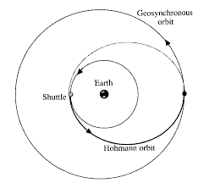

* + **Lagrangian Points**
    - **Lagrange Points are**positions in space where the gravitational forces of a two-body system like the Sun and Earth produce enhanced regions of attraction and repulsion.
    - Concept by French Mathematician Joseph Lewis Lagrange
    - There are Five Lagrangian Points in outer space that exist between two heavenly bodies, e.g. Earth and Moon, or Earth and Sun, or Jupiter and Mars, etc.
      * L1, L2, L3 are in a straight line, whereas L4 and L5 are ahead and behind the revolutionary part of the earth, making an angle of 60 degrees to the earth and sun system.
    - 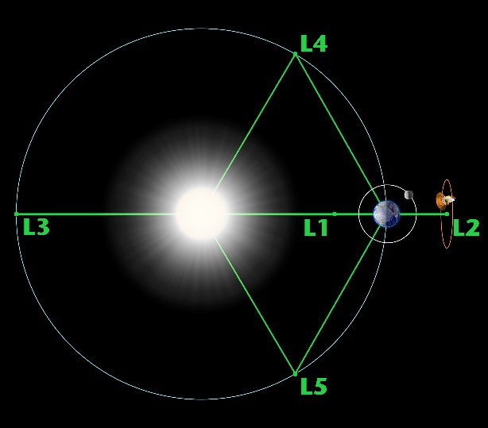

* + **Halo Orbit**
    - Halo orbit is a 3-dimensional orbit around the Lagrange Point
    - The distance of L1 Lagrange Point is about 15 lakh kilometres from Earth.
    - At present, there is a mission called: SOHO (Solar Heliosphere Observatory). It is a joint program by NASA and ESA, which is working at the L1 point.
    - SOHO is a project of international collaboration to study the Sun from its deep core to the outer corona and the solar wind.
      * SOHO was launched in 1995, NASA was responsible for the launch.
      * Now ISRO mission is going to use Aditya L1 in the future for the same.
      * NASA’s Most Advanced Astronomical Telescope: James Webb Space Telescope (JWST) will be place at Lagrange Point 2 (L2), which is back side of the Earth.
      * JWST: Observation of Deep Universe.
        + After launch, the telescope will deploy a journey to the second Lagrange point L2.

**Satellites**

* + **Natural satellites** 
    - Jupiter (92)
    - Saturn (83)

* + Moon - Earth
  + Phobos & Deimos - Mars
  + Io, Europa, Ganymede, Callisto - Jupiter (और भी है, लेकिन है औक़ात के बाहर)
    - **Europa** 
      * sightly smaller then moon
      * Most promising places in solar system to find for life beyond earth (thin layer of oxygen)
      * NASA -> Europa Clipper in 2024
      * 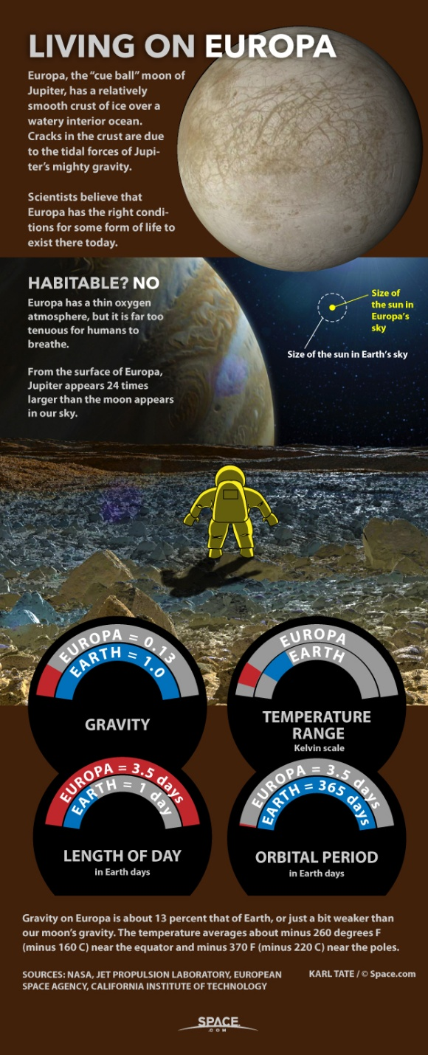

* + Mimas, Enceladus, Tethys, Dione, Rhea, Titan - Saturn
  + Ariel, Umbriel, Titania, Oberon, Miranda - Uranus
  + Triton - Neptune

* + **Artificial Satellites**
  + A satellite is a spacecraft that is placed in an orbit by a launch vehicle to carry out various types of space-related functions using instruments (payload) on board and communicating with earth.
  + It has telemetry work : Tele means far away, and ‘metry’ means measurement.
  + They may have instruments onboard, radar, spectrometer, telescope, etc.
  + Satellite types according to mass:
    - Large satellites: More than 1000 kg.
    - Medium-sized satellites: 500-1000 kg.
    - Small satellites: less than 500 kg.
    - Minisat: 100-500 kg.
    - Microsat: 10-100 kg.
    - Nanosat: 1-10 kg.
  + Picosatellite : Less than 1 kg (for example, Cubesat, and Kalamsat: 64 grams)
  + Based on applications satellites are :
    - Communication satellites: INSAT/GSAT.
    - Remote Sensing: ResourceSat, Cartosat, etc.
    - Navigation: IRNSS (NAVIC).
    - Meteorological satellites: Kalpana (Metsat).
    - UV environment: Astrosat.
    - Military: RISAT (Radar imaging satellite).

* + **Communication Satellites**
    - It is used to receive, process, and send signals to and from the earth.
    - It uses ultra-high frequency (UHF).
    - Transponders (transmitter and receiver) work for various types of frequency ranges (frequency band) to provide space communication.
    - S-band : 2 - 4 GHz (MSS, mobile satellite services, NASA, deep space research).
    - C band: 4 - 8 GHz (Fixed Satellite Service).
    - X band: 8 - 12.5 GHz (Terrestrial earth exploration, e.g. Remote Sensing).
    - Ku band: 12.5 - 18 GHz (Broadcast satellite services, DTH).

* + **Satellite Communication**
    - Radio waves travel in a straight path
    - We can use communication satellites to send receive signals.
    - We use Ultra High Frequency (UHF) radio waves, C, K, Ku bands.
    - During cloudy weather, DTH, etc. are usually attenuated.
    - Two types of communication

* + **Active Communication:**
    - The satellite receives a signal, processes, amplifies the signal, and redirects it.
    - Processing is involved.

* + **Passive Communication:**
    - Satellite does not work on signal, it simply receives it and transmits it.
    - No processing is involved.

* + **ISRO Communication System:**
    - ISRO started with INSAT (Indian Satellite System).
    - GSAT: Geo Stationary Satellite System in 1983.
    - INSAT/GSAT system is a multi-purpose satellite system with the following applications
      * Telecommunication/mobile communication.
      * TV and Radio Broadcasting (Direct to Home).
      * Tele Education/Distance online learning.
      * VSAT (Very small aperture Terminal)
    - **Tele-medicine: (Providing Health care)**
      * Telemedicine is one of the unique applications of space technology for societal benefits.
      * ISRO Telemedicine program started in 2001, has been connecting remote/rural/medical college hospitals and mobile units through the INSAT system to major specialty hospitals in cities and towns.
      * Presently, the telemedicine network of ISRO covers multiple hospitals throughout the country.
      * The mobile telemedicine units cover diverse areas of Ophthalmology, Cardiology, Radiology, Diabetology, Mammography, general medicine, women and child healthcare.
      * Multi-specialty Hospitals connected to Primary Health Centres, Mobile health units, Ambulances, e.g. GSAT 12.
      * It can provide critical care support during emergencies.
        + E.g. during organ transplantation, time-lapse can be minimized by such technology.
      * Satellites are used in meteorology.
  + **Disaster management**: Before, during and post-disaster, communication satellites can play an important role.
    - Pre-disaster:
      * Tsunami Early Warning System, Cyclone-related information can be conveyed.
      * Information related to Cyclone landfall, etc. via TV/Radio, etc.
    - During disaster:
      * Telephone lines may be damaged.
      * Evacuation etc. can use satellite technology.
    - Post-disaster:
      * Communication, coordination, NDRF teams, etc. can use.
      * Relief matter can be monitored using satellites.

* + **Satellite-based search and rescue:** 
    - India is a member of the international COSPAS-SARSAT, for providing distress alert and position location service through Low Earth Orbit Search and Rescue (LEO SAR) satellite systems.
    - Under this India has established two local user terminals: one at Lucknow and the other at Bangalore.
    - The Indian mission control centre is located at ISRO Telemetry, Tracking and Command Network, ISTRACK (Bengaluru), the system is operational for the past 23 years.
    - INSAT- 3A is used for Search and Rescue Operations, recently INSAT- 3D, an advanced meteorological satellite, is also being used for Search and Rescue Operations.
      * GSAT-11 : It weighs about 5854 kg, launched by French satellite Ariane-5 VA-246.
      * GSAT-30 : Was launched in GTO in January 2020 (3357 kg).

* + **Remote Sensing**
    - Remote Sensing is a technique to collect data of land and water using aerial platforms, helicopters, drones, planes, hot-balloons, and satellites carrying high-resolution cameras and it also uses radiation/spectrometer.
    - Using the data collected from instruments and cameras, onboard is sent to ground stations which are analysed using computers and software, e.g. arial photos, etc.
    - It is used in GIS: Geographical Information System.
    - It is used in GIS applications.

* + **Two types of Remote Sensing**
    - The first type is called active remote sensing.
    - **Active Remote Sensing:**
      * The Earth Observing Satellite sends a signal to Earth-based objects which is reflected back to the satellite.
      * The satellite transmits and receives data.
      * The second is passive remote sensing.
    - **Passive Remote Sensing Satellite:**
      * Earth Observation satellite will only receive the radiation or light from earth-based objects from the sunlight.

* + **Indian Remote Sensing Satellite System**
    - ISRO started the Remote Sensing program in 1981.
    - IRS consists of multiple remote sensing or earth observation satellites for various applications
    - Natural Resources Survey and Management.
    - Assessment of crop yield, acreage, pest infestation, etc.
    - Assessment of tree and forest cover.
    - Mangroves, vegetation, etc. assessment of water resources, esp. river, lake, wetland, etc.
    - Mineral prospecting can be done.
    - Monitoring of soil.
    - Disaster Management: Preparation of ‘Hazard Maps’ of natural calamities, etc.
    - Study of wildlife, coral reefs, etc.
    - Climate change, impacts, viz sea level rise, forest fire (California/Australia), etc.
    - Cartographic applications of satellites:
      * Preparation of maps,
      * Defence/Military forces can use the maps.
      * In India, remote sensing satellite data is used for Rural planning, township development, etc.
      * Oceanography: Remote sensing, fishing grounds, etc.
      * ISRO IRS system consists of ResourceSat, Cartosat, OceanSAT for the study of Oceans, Radar Imaging Satellites (RISAT).
      * E. g. RISAT-2BR1: For Agri, forestry, disaster management.
        + ESO-01: Earth observation satellite, intended for applications in agriculture, forestry, and disaster management support.
        + Cartosat 3: Urban planning, rural resource, and infrastructure development, coastal land use, etc.
        + HysIS: Hyper Spectral Imaging Satellite: Study the surface of the earth, in the visible, near-infrared, and shortwave regions, for: chlorophyll content, soil content, etc.
        + SCATSAT-1: Oceansat-2 Scatterometer, for oceanography, wind direction, etc.

* + **Bhuvan Platform:**
    - BHUVAN is ISRO’s Geo-Spatial Portal which provides various applications to users in terms of thematic maps, generated by data from the IRS satellite.
    - It has many versatile features, for example:
      * Visualization of satellite imagery and map.
      * Analysis of such imagery and maps.
      * Free data download, and
      * The download of reports.
      * The Satellite imageries are of multisensory, multiplatform, and multi-temporal in nature, which can be visualized in 2D and 3D.
      * BHUVAN was started in 2009.
      * Bhuvan Platform supports many applications that address governance and other geospatial applications that are being used by the central and state government departments, academia, and industry.

# 

* + **Navigation Satellites**
    - Navigation Satellites are a system of satellites used to provide autonomous Geo-Spatial positioning of objects.
    - Designed expressly to aid the navigation of Air and Sea traffic via radio waves it allows small electronic receivers to determine object location to high precision using time signals transmitted along a line of sight by radio waves from satellites.
    - A satellite navigation system with global coverage is termed a global navigation system or GPS.

* + **NaVIC (Navigation with Indian Constellation)**:
    - NaVIC or IRNSSS has been designed initially with 7 satellite systems, with satellites orbiting at 36,000 km.
    - 4 satellites in Geosynchronous orbits move in pairs, in two inclined orbits, which appear from the ground to travel in figure 8.
    - The other 3 satellites in Geostationary orbits appear from the ground to be at a fixed position in the sky.
    - It consists of three extremely accurate Rubidium atomic clocks in each satellite.
    - It provides navigation accuracy of better than 20 meters.
    - The ISRO is developing dedicated receivers to help NaVIC provide services to multiple users.
    - It covers Indian Landmass + 1500 km from the borders.
    - It cost 1420 Crore Rupees.
    - 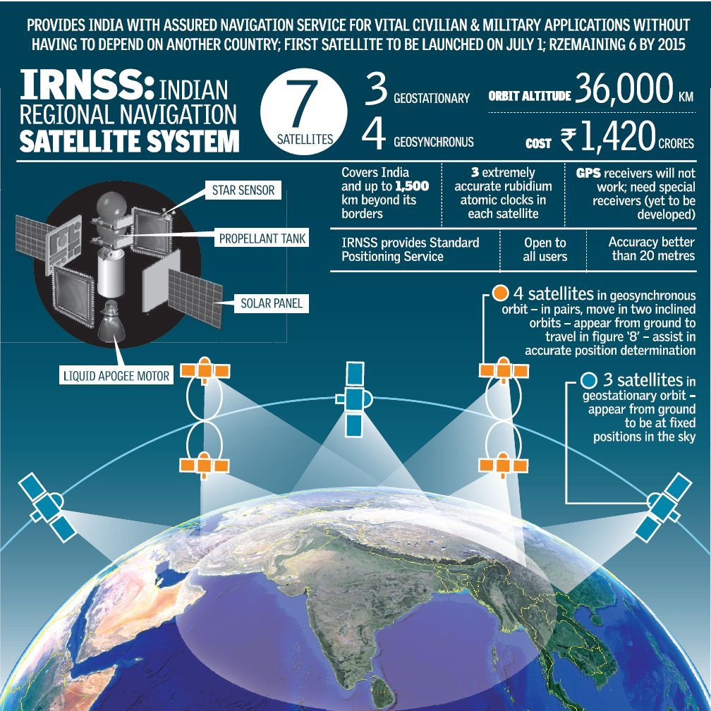

* + **GAGAN (GPS-aided GEO augmented navigation)**
    - It is a joint project of the Airport Authority of India and ISRO.
    - To provide better signalling in Civil Aviation.
    - GAGAN is an SBAS (Satellite Based Augmentation System).
    - It is made up of 3 communication satellites, GSAT 8, GSAT 10, and GSAT 15.
    - The main objectives of GAGAN are to provide satellite-based navigation services with the accuracy and integrity required for civil aviation application.
    - And to provide better Air Traffic Management over Indian Airspace.
    - GAGAN is interoperable with other international SBAS systems, such as US-WAAS, European-EGNOS, and Japanese-MSAS.
    - GAGAN geo-footprint extends from Africa to Australia and has expansion capability for continuous navigation services across the region.
    - The GAGAN signal in space is supported by the ground segment.
    - India is the third country to have such a precision approach, in terms of navigation.
    - GAGAN, though primarily meant for aviation, will provide benefits beyond aviation to many other user segments such as intelligent transportation.
      * For example Maritime, highways, railways, surveying, geodesy, security agencies, telecom industry, a personal user of location services.

* + **GEMINI**
    - GAGAN Enabled Mariner’s Instrument for Navigation and Information.
    - Early warning of cyclones.
    - Ocean forecast.
    - Potential Fishing zones can be informed by GEMINI.
    - It will enhance maritime security.
    - INCOIS : Indian National Centre for Ocean Information Services, which comes under the Ministry of Earth Sciences, also supports the GEMINI.

* + **Space Exploration**
    - **ASTROSAT**
      * India's first Multiwave space Observatory (by TIFR and ISRO), takes data in visible light, X-rays, and UV Rays.
      * ASTROSAT has 5 instruments.
      * It was launched in 2015, in 650 km low earth orbit.
      * It was meant for 5 years but later extended.

* + **Objectives of ASTROSAT**
    - To understand high energy processes in binary star systems containing neutron stars and black holes.
    - To estimate the magnetic field of neutron stars.
    - Study of star birth regions and high energy processes in star systems lying beyond our galaxy.
    - Detect new briefly bright X-ray sources in the sky.
  + 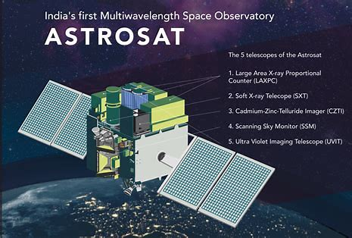

* + **Mangalyaan**
    - India’s first interplanetary exploration (Earth and Mars).
    - Five scientific instruments are on board.
      * Thermal Infrared Imaging Spectrometer (TIS)
      * Methane Sensor for Mars (MSM)
      * Mars Colour Camera (MCC)
      * Lyman Alpha Photometer (LAP)
      * Mars Exospheric Neutral Composition Analyser (MENCA)
    - **It has two broad objectives:**
      * Technological objectives:
        + Building the spacecraft, instruments, intersection to Mars orbit, etc.
      * Scientific objectives:
        + Study Martian atmosphere
        + Detecting minerals, water, gases, Methane, etc.
  + **Chandrayaan**
    - Two missions have been carried out.
    - Chandrayaan 1 was on orbiter (100 km orbit over the moon).
    - Chandrayaan 1 was launched in 2008, it was PSLV C-11.
    - Chandrayaan 2 had two modules.
      * Orbiter: working right now.
      * Lander and rover: Lander Vikram, and Rover called Pragyaan
      * We failed in landing.
      * Launched by GSLV MK-3 M1, launched in 2019.
      * Chandrayaan 2 was completely indigenous.
      * **Objectives:**
        + Launch, study chemical and mineralogical mapping of moon’s surface, etc.
        + The dark side of the moon was to be explored.
        + Finding Titanium, Silicon, etc.
        + Looking for water on Polar side.

* + **Missions on Mars:**
    - UAE: Hope
    - China: Tianwen-1
    - ESA: Mars Express and ExoMars Trace Gas Orbiter
    - Nasa: Mars Reconnaissance Orbiter, Mars Odyssey, MAVEN, Curiosity rover
    - India: Mangalyaan

* + **Gaganyaan** 
    - Four astronaut : Group Captain Prashanth Balakrishnan, Group Captain Ajith Krishnan, Group Captain Angad Pratap, and Wing Commander Shubhanshu Shukla.
    - Launch Vehicle Mark-3 (LVM3) will be used
    - Crew Escape System (CES) : to ensure crew is taken to safe distance in case of emergency
    - Orbital Module: Crew Module (CM) and Service Module (SM)

* + **Structure of Sun**
    - Core (where fusion occurs), then Radiative zone, Convection Zone, Atmosphere, Chromosphere, Photosphere, Corona.
    - The outermost part is Corona (it has millions of degrees Celsius).
    - The temperature of the photosphere: 5000 Kelvin.
      * 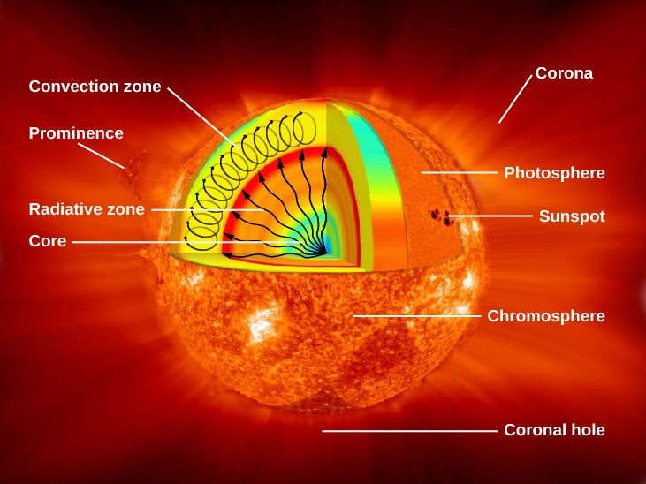

* + **Aditya L1**
    - Aditya to study the sun will be placed in a Halo orbit at the L1 point.
    - Located 15 lakh kilometres from earth.
    - There is no effect of the moon (no solar eclipse for Aditya L1)

* + **Objectives:**
    - The study temperature difference between the outer corona and inner photosphere.
    - To study coronal mass ejection/solar wind (CME).
    - To study the magnetic field and flux of Sun’s corona.
    - To study sunspots.
    - Study Solar tsunami on space weather.

* + **NISAR (NASA-ISRO Synthetic Aperture Radar)**
    - NISAR is the world’s most expensive earth imaging satellite to date ($ 1.5 billion).
    - The Radar is being built jointly by India and the USA.
    - And is expected to be launched in 2023 by GSLV Mk 2.
    - NISAR is a dual-frequency L band and S-band Radar mission, which will map earth every 12 days from two directions, north and south.
    - NASA will provide L-band whereas ISRO will provide S-band.
    - NISAR will make globally integrated measurements of the causes and consequences of the land surface changes.
    - It will provide high-resolution images of dynamic changes in land, ecosystems, and natural resources.
    - It will also provide impacts of climate change on ecosystems and polar ice and glaciers.
    - It will also study Earth’s crust and natural hazards, including earthquakes, tsunamis, landslides, and volcanoes.

# 

### Defence Technology

* + It has components:
    - Science and Technology: missiles, submarines, frigates, fighter jets, choppers, etc., the role of DRDO.
    - Security : National Security, the role of military (army, air force, navy, etc.)
    - Economy : E.g. Defence has 49% FDI. Make in India, etc.
  + **Defence Research and Development Organization (DRDO):**
    - The DRDO works under the Department of Defence Research and Development of the Ministry of Defence.
    - The DRDO dedicates its work towards self-reliance in defence systems and technologies.
    - DRDO undertakes design and development leading to the production of weapon systems and equipment.
    - DRDO is working in various areas of military technology, which include aeronautics and avionics, armaments, combat vehicles, electronics, instrumentation, missiles, naval systems, advanced computing, and life sciences.
    - More than 52 labs are working with DRDO.
    - Missile : Today India has various types of missiles.
    - Naval System : Submarine, Naval warships, Torpedo, SONAR.
    - Aeronautics and Avionics: Fighter-crafts, Helicopters, Unmanned Aerial Vehicles (Drones).
    - Advanced Materials: Carbon Composites, etc.
    - Advanced Computing: Supercomputers, e.g. Anurag Anuvrat, etc.

* + **Missile Technology**
    - Missile is a weapon delivery vehicle.
    - Which can deliver the conventional or nuclear warhead.
    - To a designated target, on land, air, or sea surface or under sea.
    - A missile is propelled to the target using a propulsion system using atmospheric air to burn the fuel or the propellant.
    - India’s Indigenous Missile Development Programme started in 1983, called as Integrated Guided Missile Programme, under Dr. APJ Abdul Kalam.

**Classification of Missiles**

* + Depending on the environment from which the missile is launched and the environment in which the target is to be found, guided missile systems are classified as follows:

**Ballistic Missile**

* + It follows a sub-orbital/projectile path.
  + It follows the law of gravity.
  + It has two phases:
    - Exo-atmospheric,
    - Endo-atmospheric.
      * For E.g.: the Prithvi Series, Agni Series of missiles.
  + They are long-range missiles.
  + Advantages : Can be used for various ranges (short and long ranges).
    - Fuel consumption is less.
    - Require fuel only when it is going against gravity.

**Disadvantages of Ballistic Missiles:**

* + More suitable for fixed targets.
  + Can be intercepted by Radar, and destroyed in the air by anti-ballistic missiles (e.g. by S-400).

**Quasi ballistic missile**

* + Somewhat manoeuvrability, low trajectory
  + Missile - Pralay
    - Part of प्रहार missile program

**Cruise Missile**

* + It follows a sea-skimming trajectory.
  + It moves close to the surface, maintaining a distance from the surface.
  + For E.g.: India-Russia’s Brahmos, Nirbhaya.
  + Advantages : Speed and manoeuvrability are high.
    - The inability of normal radars to intercept it.
  + Guided to the target in air, land, water surface accurately.

**Disadvantages of Cruise Missiles:**

* + Suitable for short and medium ranges.
  + Consumes more fuel.
  + Have lighter payloads.

**Based on Launch and Target Sites**

* + Surface to Surface Missile (SSM):
    - Ballistic and Cruise examples:
      * E. g. Prithvi 1, 2, and 3, Agni 1 to 5, also Brahmos.
  + Surface to Air Missile (SAM):
    - They are non-ballistic.
    - They hit the air targets, e.g. Akash, Trishul.
  + Air to Air Missile: (AAM)
    - Used by fighter jets and combat helicopters.
    - For example: Tejas can have AAM.
      * AAM examples: Astra.
        + 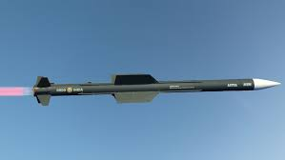

* + Air to Surface Missile (ASM):
    - It is launched from air.
      * For example: Helina: Helicopter launched NAG (use of NAG missile)
      * A helicopter called Dhruv uses Helina.
      * Helina can destroy battlefield tanks.
      * 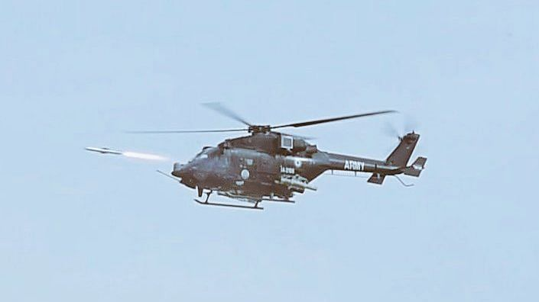
      * Similarly, Brahmos can be used as ASM.

**Based on Range of Missile**

* + Short Range: Less than 500 km.
    - For e.g.: Prithvi-1 (Surface to surface missile with Range of 150 km)
      * NAG (Anti-tank Guided Missile with range of 7 km).
      * Brahmos (Supersonic Cruise Missile with range of 290 km).
  + Medium Range: 500 to 1500 km.
    - For example: Nirbhaya (Sub-sonic cruise missile with a range of 1000 km)
    - Agni-2 (Surface to surface missile with a range of 2000 km)
  + Intermediate-Range: (2000 km to 5000 km)
    - Agni Prime missile - smallest and lightest among the entire Agni series
      * two-stage canisterised solid-propellant missile
    - For example: Agni 3 (SSM with range of 3000 km)
      * Agni 4 (SSM with range of 4000 km).
  + Long Range: (more than 5,000 km)
    - For example Agni 5: (SSM with a range of 5000 km)
    - Agni 5 is an Inter Continental Ballistic Missile.

**Based on the speed of the Missile (1 Mach= 332 m/sec**)

* + Sub-sonic: Less than 1 Mach
    - For example: Nirbhay (0.7 Mach, it is difficult to detect with radar).
  + Super-sonic: (between 1 Mach to 5 Mach)
    - For example: Brahmos Supersonic Cruise Missile with a speed of 2.8 Mach.
  + Hyper-sonic: (more than 5 Mach)
    - For example: Brahmos-II, Shaurya, Agni-5 missile.

### Air Defence System

* + To develop an advanced Radar System to intercept any incoming enemy rocket or missile.
  + Placing the Anti-Ballistic Missile System to destroy the incoming missile in the atmosphere.
  + To destroy it in exo-atmosphere (80 to 150 km) or endo-atmosphere (12-15km).
  + By two modes:
    - Hit to kill.
    - By proximity detonation.
      * In exo-atmospheric, we can use proximity detonation.
      * But hit-to kill can be used in both Exo and endo atmosphere.
    - Three countries currently possess this technology:
      * US: THAAD (Terminal High Altitude Advanced Area Defence System) and Patriot.
      * Russia: S-200, S-300, and S-400 km.
      * Israel: Iron Dome.
    - **India is developing:**
      * Prithvi Air Defence (for exo-atmosphere), Pradyumna Missile
      * CADETS DEFENCE 
        Prithvi Air Defence (PAD) 
        (Pradyumna Ballistic Missile Interceptor) 
        Exo-atmospheric Anti-ballistic missile 
        Range:- 80 Km Altitude 
        is an anti-ballistic missile developed to 
        intercept incoming ballistic missiles 
        outside the atmosphere (exo-atmospheric). 
        Prithvi Air Defence (PAD) missile test on 
        6 December 2007 from the Integrated 
        Test Range (ITR) at Chandipur. 
    - Advanced Air Defence (for endo-atmosphere), hit to kill, Ashwin Missile.

* + **Submarine Launched Ballistic Missile:**
    - SLBM with short, medium, intermediate ranges can be used to deliver a nuclear warhead to targets on the sea surface and land surface (coastal area targets and beyond).
    - K4: 35,00 km.
    - K15 Sagarika: 700km.
    - INS Arihant (Nuclear Powered Submarine carries K4 and K15 Sagarika Missiles.)
    - INS Arihant is also called SSBN (Ship Submersible Ballistic Nuclear) because it carries nuclear-tipped SLBM.
    - It provides India with Nuclear Deterrence Capability.
    - It also provides India with second-strike capability.
    - This completes our nuclear triad.

### Naval Systems

**Submarines**

* + 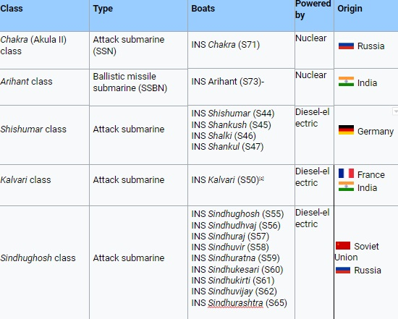

* + **Russian Submarines:**
    - Diesel-electric powered. Like: INS Sindhu-Ghosh, INS Sindhurakhask.
    - Nuclear powered submarines: Akulya Class or Charlie Class for example INS Chakra (engine uses nuclear power).
  + **French Submarines**:
    - **Project 75-i:** MoU signed between a French Company called Naval-Group (DCNS), and Mazgaon Dock Limited (MDL), Mumbai.
    - Under the Make in India program, we have invited the company Naval Group, six Scorpion-Class Submarine are built here. (INS Kalvari, INS Khanderi, INS Karanj, INS Vega, INS Vageer, INS Vagsheer)

* + **Features of Scorpene-Class:**
    - Fast Attack submarines.
    - Diesel-Electric Powered.
    - Air independent propulsion system (AIPS) via Fuel Cell technology.
  + **India:**
    - Nuclear Powered Submarine:
    - INS Arihant, INS Arighat, INS Aridhman.
    - Indigenous Nuclear Powered submarine INS Arihant.
      * It uses an 85 Mw Pressurized water reactor which uses 45% enriched Uranium, developed by BARC.
      * It is the indigenization of a Russian Charlie class nuclear-powered submarine called INS Chakra.

* + **SONAR System**
    - **Sound Navigation and Ranging.**
    - The ultrasonic sound gets reflected from undersea objects to locate it.
    - Helps in the navigation of submarines and detects obstacles or threat undersea.
    - Two modes of working of SONAR
      * Active SONAR : Sends and receives the sound signal.
      * Passive SONAR : Only receives or intercepts incoming sound signal.
    - **Types of SONAR :**
      * Submarine SONAR : For example USHUS.
      * Hull-mounted SONAR : (HUMSA) is a ship-based SONAR.
      * Towed-Array SONAR : The SONAR system is towed by a ship via cable.
      * Dunking SONAR : E.g. Low-Frequency Dunking SONAR (LFDS)

* + **DRDO’s MAAREECH**
    - It is an anti-submarine warfare system.
    - It is an advanced Torpedo Defence System.
    - Is a torpedo detection and countermeasure system.
    - It uses an advanced sound system, to decoy and diverts the torpedo of the enemy submarine.
    - To protect the Indian Naval ships.

* + **VARUNASTRA**
    - It is a heavyweight indigenous torpedo system developed by Naval System and Technology Lab.
    - To destroy the littoral and deep water stealth submarines.

* + **INS Astradharini**
    - It is a torpedo launch and recovery vessel.
    - Recovery of torpedoes which are used for naval training purposes.
    - It is developed in collaboration with IIT Kharagpur.

* + **Warships**
    - **Destroyers**
      * They are large warships for a combat operation.
      * They carry helicopters like Chetak, artillery guns, radar, torpedoes.
      * They carry surface to surface missiles
      * They use DHANUSH (Naval version of Prithvi II missiles, Brahmos, etc.)
      * They are used in wartime.
        + For example Project 15 B: INS Kolkata, etc.
    - **Frigate**
      * Small-sized fast-attack vessels with stealth features.
      * They are stealth systems.
      * Carries missiles.
        + For example Talwar class Frigates, etc.
    - **Corvette:**
      * They are meant for anti-submarine warfare.
      * They can detect and neutralize undersea submarines, by using advanced torpedoes.
      * For example, Garden Reach Company in Kolkata is developing INS Kamota, Kalpeni, etc.
    - **Aircraft Carriers**
      * Biggest naval warships with docks and runways.
      * They can carry aircraft like LCA Tejas, Migs, etc.
      * For example, INS Vikramaditya (Admiral Gorshkov), INS Vikrant

### Electronic Warfare

* + Design and development of sensors, devices, and systems, to intercept signals (voice, radio, etc.)
  + To locate hostile targets using Advanced RADAR systems.
  + **Jamming** of the signal is also done (e.g. Jammers).
    - Jamming is done to protect military assets from any attack from the enemy.
  + **Surveillance** systems are also part of electronic warfare.
    - 2-D low level Radar: Bharani.
    - 3-D low-level Radar: Aslesha
    - 3-D Surveillance Radar: Rohini.
    - 3-D Surveillance Radar (for Navy): Revati.
    - Weapons Locating Radar: Swathi.
    - Coastal Surveillance Radar System.

**Airborne Early Warning and Control System: (AEW&CS)**

* + It is based on the Phalcon system of Israel.
  + DRDO has built AESA (Active Electronically Scanned Array) Radar fixed on the top of an aircraft
  + Earlier we bought: Embraer from Brazil, later Ilyushin aircraft from Russia (converted into NETRA).
  + Help in the survey in the sky of any threat in the air on land and on sea-surface and provide early warning to military units.

* + **Fighter-crafts**

**Russia:**

* + Mig 21, 27, and 29.
  + Sukhoi: Su30 Mk1

**France:**

* + Mirage 2000
  + Rafale:
    - 36 Rafales were bought from Dassault Aviation.
    - Rafale is a Multimode Role Combat Aircraft.
    - Rafale can be used day and night.
      * Refuelling in the air is possible.
      * It can have air-to-air missiles, or BrahMos air-to-surface missiles, bombing the land.

**India:**

* + Light Combat Aircraft (Tejas)
    - Designed and developed by HAL.
    - Made of composite material.
    - It can be used for both Airforce and the Indian Navy.
  + Fly-by-wire control system (Automated flight guidance system).
  + Tejas: We are negotiating with France to acquire a Kaveri engine.
    - Presently Tejas is not using the Kaveri engine (currently using the General Electrics/GE engine).

* + **Helicopters:**
    - Prachand - light combat helicopter
    - Chetak: Also used for VVIP movement, Relief operations, Personnel Movement, etc.
    - Advanced Light Helicopters (ALH) e.g. Dhruv
    - Light Combat Helicopter (LCH).
    - Apache (AH64E): USA, Combat Helicopter, Gun, missile.
    - Chinook: the USA, a Heavyweight, lift helicopter, carry logistics, transport of troops, etc.
    - Mi-17: Russia, Combat Helicopter

* + **Unmanned Aerial Vehicle: (UAV)**
    - Remotely controlled and pilotless vehicle.
    - It is controlled by a ground-based operator.
    - They are also called drones.
    - It has both civilian and military applications.
    - Civilian: Aerial photography, videography, cinematography, delivery of e-commerce, law, and order.
    - Military usage: Target Acquisition and Designation, Reconnaissance, Surveillance, monitoring, combat operation, damage assessment, search and rescue.

**DRDO has developed the following UAVs:**

* + Lakshya,
  + Nishant (can fly in dark).
  + Panchi: Wheeled version of Nishant.
  + Rustom-1 (12 to 14 hrs in the air), and Rustom-2 (it can remain 24 hrs in the air). They are MALE: Medium Altitude and Long Endurance drones.

### Nuclear Science and Technology

* + Elements have atoms.
  + Every atom has a nucleus.
  + The nucleus has protons and neutrons
  + Nuclear reaction :
    - Nuclear reactions can be divided into two types:

**Fission reaction:**

* + In a fission reaction, the heavy nucleus of an atom disintegrates/breaks down, into two or more lighter daughter nuclei, with the release of energy.
    - For E.g. of Uranium.
  + For example, the isotope of Uranium, i.e. U-235 captures slow neutrons and produces daughter nuclei of Barium and Krypton and 3 neutrons.
    - UBaKr-235-144-89 (सुभाकर)
    - 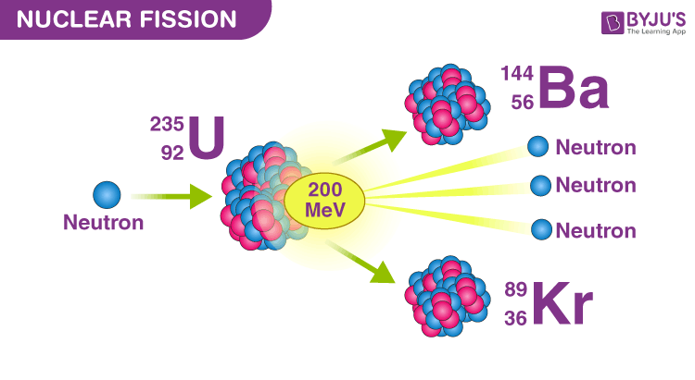

**Uncontrolled Fission (Chain reaction)**

* + We don't control fission reaction, e.g. Atom Bombs, weapons, it has a lot of energy.

**Controlled Fission Reaction (controlled chain reaction)**

* + Nuclear power generation
  + In a nuclear reactor

**Fusion reaction:**

* + Two lighter nuclei of atoms combine together to form a stable heavy nucleus.
  + They require very high temperatures, hence is called a thermo-nuclear reaction.
  + 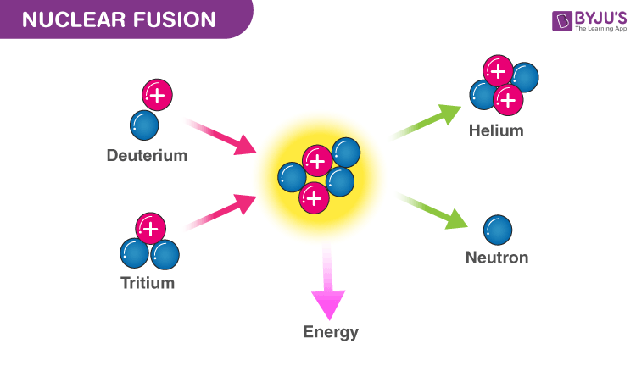

* + For E.g. inside the Sun.
    - Fusion of hydrogen nuclei to form Helium.
  + **Uncontrolled Fusion Reaction:**
    - It happens in Sun/Stars, the source of energy is an uncontrolled fusion reaction.
    - Also, Hydrogen Bomb is an uncontrolled fusion bomb. (Plutonium based fission is used to increase temperature, and then hydrogen is used to combine to produce helium)
  + **Controlled Fusion Reaction:**
    - It is possible by the use of controlled reactors. For example: Plasma research in a Tokamak reactor.
    - **Tokamak Reactor:**
      * It is a Toroidal shaped Reactor to generate very high-temperature plasma inside the reactor vessel.
      * It generates a very high temperature inside the Reactor by using ‘magnetic induction’.
      * Strong magnets are used.

**Artificial Sun**

* + China has developed the Tokamak Reactors called EAST (Experimental Advanced Superconducting Tokamak) and HL-2A, to produce fusion on earth.
  + EAST has achieved the highest temperature which is similar to that of sun (millions of degrees centigrade).
  + EAST is a part of ITER (International Thermonuclear Experimental Reactor).
    - ITER is a Cadarache, France-based project.
  + Institute for Plasma Research (IPR), Gandhinagar has
    - Aditya Tokamak
    - Aditya U
    - SST-1

**ITER Project**

* + By 2035 ITER Project will be ready for power generation using Deuterium in Fusion Reaction under controlled energy.
  + Due to this fusion heat, energy will be released, which will boil water into steam to run turbine generator to produce electricity.
  + **Advantages of Fusion Reactor:**
    - Fusion is clean energy.
    - The end product is Helium (non-radioactive).
    - High power generation.
    - Sustainability.
    - No problem with respect to radioactive nuclear waste disposal.
  + **Challenges:**
    - It requires very advanced technology.
    - China developed fusion for only 20 seconds.

**Nuclear Reactor**

* + A nuclear reactor is a thermal power reactor to produce heat energy, inside the core of the reactor.
  + This is done by using a controlled nuclear fusion chain reaction of natural Uranium.
  + The heat energy obtained from the fission reaction boils water into steam to run a turbine generator.
  + To produce electricity.

**Components of a Nuclear Reactor**

* + A nuclear reactor has four important components:
    - Fuel, which is consumed (e.g. Uranium, Plutonium, Thorium can be used).
    - Fuel is packed in Fuel Rods Assembly and kept inside the core of the Reactor.
    - Moderator : Heavy water D2O is used to slow down the fast-moving neutrons, to be captured by uranium-235.
    - Coolant : Normal light water, heavy water, liquid Sodium is used to extract heat energy, keep the temperature of the core under the limit.
    - Controller Rod : Boron or Cadmium rods are used. To absorb neutrons to control no. of reactions.
  + 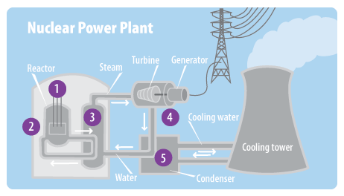

**Department of Atomic Energy (DAE)**

* + DAE was established in 1954.
  + To support the atomic energy program in India together with scientific research in nuclear science and technology.
  + And the application in agriculture, healthcare, industry, environment, and water.
  + DAE works under PMO.
  + Presently India generates about 7000 MW of electricity using 22 Reactors operating in 8 Nuclear Parks.
  + Recently Cabinet has approved the construction of 10 more Reactors which will add 7000 MW of electricity to the existing Nuclear Power.
  + Existing Nuclear Parks in India:
    - Trombay (BARC): Maharashtra.
    - Tarapore (BARC): Maharashtra.
    - Narora: Uttar Pradesh.
    - Rawatbhata, Kota: Rajasthan.
    - Kudankulam: Tamilnadu.
    - Kalapakkam: Chennai, Tamil Nadu.
    - Kiaga: Karnataka.
    - Kakrapar: Gujarat

**New Nuclear Parks**

* + Jaitapur: 6x1670 MW European (NPCIL and Areva) Pressurized Reactor (EPR), France (Maharashtra).
  + Kumahriya (Haryana)
  + Kovada (Andhra Pradesh)
  + Bhimpur and Chutka (Madhya Pradesh)
  + Mahi-Banswara (Rajasthan)
  + Haripur (West Bengal).
  + Presently India’s Nuclear power stands Fourth after Coal, wind, and hydropower.

**Positives of Nuclear Energy:**

* + Clear Energy in terms of zero GHG emission.
  + High Power generation capacity.
  + Meeting India’s commitment of the NDC of the Paris Agreement.
  + Can be used for duel purposes (Civilian and Military).
  + Abundant Thorium Reserves (for 200 years).

**Negatives:**

* + Huge nuclear waste generation.
  + Handling, disposal issues.
  + Risk of nuclear accidents, sabotage, and other nuclear emergencies.
  + Huge land acquisition and protests against land acquisition.
  + Huge investments.

**India’s 3-stage Nuclear Power Programme**

* + Given by Dr Homi Jahangir Bhabha.
  + **Stage 1:**
    - Pressurized Heavy Water Reactor (PHWR) Fuel: U-235 and U-238 (3%-5% undergo fission).
    - Some convert into Plutonium, and mostly U-238 is left.
    - After reaction: U-238 and Pu-239.
  + **Stage 2:**
    - Fast Breeder Reactor (FBR) Technology:
    - Fuel: U-238 and Pu-239.
    - A fast beam of neutrons converts U-238 to Pu-239.
    - Hence, the reactor breeds the U-238 to Pu-239.
    - Hence, U-238 which is non-fissionable can be converted into fissionable Pu-239.
    - We can also convert Thorium (232) into Uranium-233.

* + **Stage 3:**
    - India has 25% reserves of Thorium in Monazite sand, found at beaches of Kerala.
    - Advanced Heavy Water Reactor (AHWR) will use Thorium as fuel.
    - Fuel: Th-232 and Pu-239 or Th-232 and U-233.
    - Thorium itself is not a fissile material, it needs to be first converted (U233) by transmutation in a reactor fuelled by other fissile material.
  + **Chinese development** 
    - Fourth-generation nuclear plant - high-temperature reactors cooled by gas instead of pressurized water.

**Nuclear Fuel Cycle**

* + The nuclear fuel cycle is a series of processes and related facilities to generate nuclear power
    - It has two divisions - Front end and backend
      * The front end of this cycle includes mineral exploration, mining and processing of the ore and fuel fabrication
      * Reprocessing of the spent fuel and management of nuclear waste hence form the backend of the cycle
      * Heavy water production and use is an auxiliary stage of the cycle
      * Any country which has developed the entire fuel cycle is capable of using nuclear technology not only for power generation but also enrichment of uranium for military purpose

* + **Context**:
    - International Atomic Energy Agency (IAEA) is the nuclear watchdog which is based in Vienna
    - Iran Nuclear Programme and the issue of UN's Non-Proliferation Treaty (NPT)
    - NPT allows peaceful use of Nuclear technology
      * Also, prohibits of keeping weapons and stockpiles by members countries except for P5
    - India is not a member of NPT along with Pakistan, Israel, etc
  + **Stages**:
    - 1. Survey and exploration - Atomic Minerals Directorate (AMD), located in Hyderabad which comes under the Department of Atomic Energy
    - 2. Mining and milling - Uranium Corporation of India Limited (UCIL), Jaduguda
    - 3. Enrichment - Ultra-centrifugation
    - 4. Fabrication (Fuel Rods) - Nuclear Fuel Complex, Hyderabad
    - 5. Nuclear Power Generation -  Nuclear Power Corporation of India Limited (NPCIL)
    - Production of Heavy Water (D2O) - Heavy Water Board, Mumbai
    - 6. Reprocessing of spent Fuel - Un-used uranium and radio-isotopes are extracted; unused uranium is again sent for enrichment
    - 7. Nuclear Waste Management - Bhabha Atomic Research Centre (BARC)
      * Here, storage of nuclear waste in a container and dumped under the earth in a deep geological formation

**Nuclear Safeguard**: It refers to the non-diversion of Nuclear Peaceful Program into military Program

**Criticality -** Condition in which nuclear fuel sustains a fission chain reaction.

* + A reactor is said to be at a critical stage when each fission releases a sufficient number of neutrons to sustain the ongoing series of nuclear reactions.

**3 Stages of Nuclear Programme**:

* + **Stage I - Pressured Heavy Water Reactor (PHWR)**
    - It is a nuclear power reactor, commonly using low enriched Natural Uranium as its fuel and heavy water as its coolant and moderator
    - The heavy water coolant is kept under pressure, allowing it to be heated to higher temperatures without boiling, which passed through another chamber to generate steam
    - The steam runs a turbine, generator, etc to produce electricity
    - The PHWR produce 700 MW of electricity
    - NPCIL operates such reactors in India in different nuclear parks
    - The spent fuel is reprocessed to extract Uranium-238 and Plutonium for the Second Stage of the Nuclear Programme

* + **Stage 2 - Fast Breeder Reactor (FBR):**
    - Not all isotopes of Uranium are fissionable
    - Uranium -238 is not fissionable but is found in 99.3% of the mined Uranium ore
    - The second stage use FBR backed by reprocessing plants and plutonium-based fuel fabrication units
    - FBR produces more fuel than it consumes
    - It can crease utilisation of the fuel by about 60%, then PHWR
    - FBR use plutonium for power generation which is obtained from irradiation of Uranium - 238 by fast neutrons
    - It is cooled by liquid Sodium
    - FBR has been developed IGCAR, Kalapakkam where the programme started in 1984
    - It generates 500 MW of electricity
    - Another government PSU, named BHAVINI has been formed to operate the FBR
    - FBR can also be used to convert thorium into Uranium - 233, which can be used as fuel in the third stage
    - Prototype FBR in Kalapakkam is nearly complete

* + **Stage 3 - Advanced Heavy Water Reactor (AHWR)**:
    - Thorium utilisation is a long term core objective of the Indian Nuclear Power Programme for providing energy security on a sustainable basis
    - BARC has developed AHWR to utilise huge stocks of thorium found in India
    - AHWR is a vertical pressure tube reactor capable of generating 300 MW of electricity
    - It uses heavy water as a moderator but is cooled by normal water
    - The fuel consists of partly thorium mixed with plutonium and partly thorium mixed with uranium

**Other applications of Nuclear Technology**

* + **1. Agriculture and Food Processing:**
    - High Yield Varieties (HYV) of Crop (Trombay Crop Varieties)
      * Seeds are irritated with radiation and radiation results in mutations
      * Screening out of mutated seeds which are HYV e.g. Akola Groundnut (TAG-24)
      * Low dose and high dose of radiations to process various types of foods with following benefits:
        + It prevents sprouting in tubers
        + Increase shelf-life of food items e.g. reservation of Litchi, Mango, etc
        + Germicidal effect
        + Prevents spoilage of foods
      * Negative Aspect: Irradicated food impacts health - certification and labelling

* + **2. Healthcare:**
    - Diagnosis of disease using radio-tracer viz Na-24; P-16; N-15, etc
    - Instruments to detect the tumour, cancer - PET (Positron Emission Tomography) which uses positron (anti-particle of electron); SPECT (Single Photon Emission Computed Tomography)
    - Radiation therapy using radio-isotypes e.g. Co-60; I-131, etc
    - Bhabhatron II - teletherapy machine to treat cancer by using Co-60

* + **3. Industry:**
    - Scanning machines to find out defects or crack in the metallic structure, leakage in oil/gas pipeline, etc
    - Electron Beam produced by Cyclotron or Synchrotron used in metallurgy (accelerator)
    - Flow measurement of liquids, the deposit of sediment, etc

* + **4. Environment:**
    - NISARGA RUNA Technology - It is a bio-methanation plant to generate bio-gas (methane) using nuclear hygienisation of bio-degradable municipal solid waste viz food wastes, spoiled food, paper, grass, biomass, etc
    - Leftover sludge can be used in agricultural land as Green manure
    - It has been used for the first time in Vadodara, Gujrat

**Research Reactors:**

* + BARC use a number of research reactors for the development of new technology which comprises a wide range of commercial nuclear reactors; production of radio-isotopes for nuclear medicines; neutron beam for research and training purpose
  + Research rectors are simpler in design than nuclear power reactors and operate at low temperatures
  + They need far less fuel and fewer fission products
  + It requires less amount of uranium and has a very high power density in the core
  + Like power reactors, the core needs cooling, though only the higher powers test reactors need a forced cooling
  + As neutron production is the main function, most research reactors use fewer moderator and controller components
  + Important research rectors are - APSARA, DHRUVA, CIRUS, PURNIMA, ZERLINA and KAMINI
  + Apsara upgraded is the indigenous swimming pool type research reactor built at BARC for research in nuclear physics, material science and radiation shielding; production of radio-isotopes for medical applications
  + The earlier APSARA was built in 1956, which was ASIA's first research reactor was decommissioned in 2009, etc

* + Age of CBRN - Computing, Biotechnology, Robotics & AI; Nano Science and Technology
  + Computing - Quantum Computing; Grid Computing and Super Computing

### Nano Science and technology:

* + Nano Science is the scientific study of atoms, molecules or molecular assembly or aggregate exiting between one to 100 nanometres (NM)
    - 1 NM = 10-9 metres
  + **Properties**:
    - Chemical reactivity; for example Catalysis as surface area increase in nano-platinum
    - Thermal conductivity - for example for carbon nano-tube (CNT)
    - Electrical conductivity - for example Graphene (2-Dimensional Graphite)
    - Optical Property - Quantum Dot (semi-conducting atoms that emit light of different colour); QLED

* + **Nanotechnology**
    - It is the design, fabrication and development of nanoparticles and nanomaterials for various applications
    - **2 Approaches:** Top-down approach and Bottom-up approach
      * Nanotechnology manipulates individual atoms, molecules or molecular clusters into structures to create materials and devices with new or vastly different properties
      * Nanotechnology can work from top-down (which means reducing the size of structures to the nano-scale For example nano-electronics)
      * Or bottom-up (which involves manipulating individual atoms and molecules into nanostructures and making them resemble more closely to biological materials such as proteins)

* + **Applications of Nano-technology**:
    - Biotechnology: Nano-capsule to deliver the drug to target cells; DNA Nano-chips
    - Healthcare: Nano-gold for the treatment of cancer; Nano-composite body implant (prosthetics)
    - Defence: Lightweight; Nano-composite material; Nano-weapons; colour changing polymers(Q-Dot)
    - Space Technology: For example Lightweight spacecraft, launch vehicle
    - Consumer Products: Nano-filters for water purification; Glass screen;  smart fabric
    - Energy: Solar panels made of nano-silicon or Germanium or nano-photo diode; battery of fuel cell

**Graphene**:

* + It is a form of carbon allotrope consisting of two dimensional (2-D) structure arranged in a honeycomb lattice
  + It is composed of carbon atoms linked in a hexagonal lattice
  + Properties of Graphene:
    - Good conductor of heat and electricity
    - Nearly transparent
    - High tensile strength
    - Better conductor compared to copper
  + Applications:
    - It includes paints and coatings; lubricants;
    - Capacitor and batteries
    - Display materials and solar cells, etc

**Carbon Nanotubes (CNT):**

* + CNT is a cylindrical hollow fibre made of a single layer of Graphite i.e. Graphene
  + It has a diameter of 0.7 NM to 50 NM with lengths generally in the range of tens of microns
  + Being a hollow tube composed entirely of carbon, they are also extremely lightweight
  + They have potential use in electronics, optics and other fields of material science

* + **Applications**:
    - It is used with other metals in making nano-material structures with high electrical properties
    - It is used as a composite coating to enhance corrosion resistance
    - It is used in the electronic packaging industry; automobile industry; gears, brake shoes, piston rings;
    - Sports Industry - badminton and tennis racquets; lightweight bicycles
    - Aerospace industry - Landing gears and aircraft brakes
    - Space applications - Structural radiators and antenna
      * Also used in sensors, battery and energy storage devices

* + **Negative aspects of Nanotechnology**:
    - Nano-particles in the environment (soil, water and air) can be easily transported to long distances and thereby causing large scale impacts as pollutants
    - As pollutant harm caused to the environment, animals and plants
    - Nano-particles  can enter the food chains and cause bio-magnification
    - Nano-particles can trigger the formation of reactive free radicals inside the human body
    - Misuse of nano-weapons for example Biological weapons using pathogens such as virus, bacteria, etc
    - Socio-economic issues in terms of developed nations using more nano-technology products causing the issue of haves and have nots
    - High technology requires high investment (expensive in nature)

**Government Initiatives**:

* + Nano-Mission was started in 2007 under the supervision of Prof CNR Rao with funding of Rs 1000 crores from DST for the period of 5 years (2007-2012)
  + The second phase (2014-2020) with additional funding of Rs 650 Crores
  + India is 3rd ranking country after the USA and China in nano-technology publications

* + **Objectives**:
    - Infrastructure development e.g. labs, academic centres, etc
    - HRD and Skill development e.g. post-graduate degrees; PHDs and Post and Postdoctoral fellowship
    - Public-private Partnership in R&D
    - International Collaborations in R&D
    - Support to start-Ups

**Robotics**:

* + A robot is a programmed machine to perform a task automatically
  + Robotics is the branch of technology that deals with the design, construction, operation, and application of robots
  + Robotics is the field of "mechatronics" i.e. mechanical engineering, electronics and computer science and engineering

* + **Advantages**:
    - 24X7 doing task
    - Automation
    - High precision and accuracy
    - High reliability

* + **Types of Robots**:
    - Manually controlled or semi-automated or fully automated
    - Stationary or mobile
    - Industrial robots - packaging, assembly line, manufacturing, cutting, welding, etc
    - Medical Robots - Robotic surgery with advantage of less blood loss; precise surgery; fast recovery
    - Military robots - Robo-soldiers; surveillance, etc
    - Space robots - Rover on mars e.g. curiosity, Insight, Perseverance
    - Domestic Robots - cleaning, Guard/Security, etc
    - Hazard Occupation Robots - Handling of nuclear waste, Deep Sea Exploration, Fire Control, etc
    - Disaster management Robots - Search and rescue, assessment of calamities; impacts, etc

**Humanoid Robots**:

* + These have a human-like body resemblance
  + Android (Asimo by Honda) and Gynoid (e.g. Sophia)
  + Mitra and Mitri (Invento Robotics), etc
  + Comprise "sensors" to sense its environment
  + Artificial intelligence - human thinking, speech, etc

**Artificial Intelligence (AI)**

* + AI refers to the branch of computer science that enables computer systems, devices, appliances, etc to process information and produce outcomes that a human would
  + An AI system learns from experience, uses the learning to reason, recognises images, solves complex problems, understands languages and create various perspectives
  + Robotics is also a major field related to AI
  + AI is based on Machine Learning and Deep Learning

* + **Machine Learning (ML)**:
    - ML is the field of computer science that often uses statistical techniques to give computers the ability to "learn with data", without being explicitly programmed
    - The term was coined by Arthur Samuel in 1959
    - ML use an algorithm to recognise the pattern of data and learn from such data to provide day-to-day life solutions
    - ML contains deep learning which enables present-day AI systems

* + **Deep Learning (DL):**
    - It is a branch of ML that uses neural network models to understand large amounts of data
    - It can accelerate processes such as image and speech recognition and natural language recognition
    - Applications of DL:
      * Governance - DL can help in policy formulation for various government programmes
      * For example officers under Swachh Bharat Mission can upload pictures of toilets which AI can flag in terms of the design parameters
      * Financial Services - For example early detection of financial risk and systematic failures
      * Product Manufacturing - For example, reliable demand forecasting, supply chain management and inventory operations
      * Defence and security - For example protecting infrastructure such as airports, power plants, by detecting anomalous behaviour in humans
      * Transport sector - For example autonomous vehicles or driverless cars

**Negative Aspects of Robotics and AI**

* + Loss of jobs and unemployment in the industry with use of automation particularly manual works
  + Accidents caused by robots
  + Misuse of robots for illegal and wrongful activities
  + Expensive in terms of installation, operation, maintenance, etc
  + Used better by big sized industries and not small and medium scale enterprises create competitive advantage
  + Ethical issues with robots, etc

**3-D Printing**

* + It is also called the Additive Manufacturing technology
  + In a 3-D printer, an object is created by laying down successive layers of material until the object is created
  + Each of these layers can be seen as a thinly sliced horizontal cross-section of the object
  + It uses materials such as plastics, metals, etc to convert products as designed on the computer to real 3-D objects

* + **Benefits**:
    - Creation of light objects or items
    - Creation of complex designs objects which would be expensive to manufacture by using a traditional mould, dies, milling and machining
    - It has multiple applications like aerospace. healthcare, product development, bionic body parts, etc
  + **Negatives**:
    - Expensive Device
    - Time required to print in large Quantity
    - Human labour in feeding raw materials
    - Misuse in making weapons

**Material science**

* + A polymer is a large molecule composed of repeating structural units called monomers.
  + These monomers are linked together through chemical bonds to form long chains.
    - E.g. Cellulose
  + The degree of polymerization (DP) is a measure of the length of a polymer chain.
  + Advantages of polymers

**Augmented Reality (AR) and Virtual Reality (VR)**:

* + AR is basically virtual reality created on real-world objects
  + The real world enhances with digital objects through applications
  + VR is an immersive technology that eliminates a person from the real world to experience the virtual environment
  + VR Set (HeadBox) worn to experience the outside world

* + **Applications**:
    - Training Purpose viz pilot, surgeon,
    - Education eg as a teaching aid to students
    - Video gaming and Tourism

**Blockchain Technology and Cryptocurrency**:

* + The data/information is stored cryptographically in a series of blocks and developed on smart contracts
  + Any change made in a single block invalidates the entire series of blocks
  + It is a kind of digital ledger stored in the decentralised system
  + Blockchains are open distributed ledgers that can chronologically record transactions between two parties efficiently in near real-time
  + The pre-requisites for each subsequent transaction to be added to the ledger is the respective consensus of the network participants called nodes
  + Thereby creating a continuous mechanism of control regarding manipulation, data quality and errors
  + Blockchain technology generally has key characteristics of decentralisation, persistency, anonymity and audibility

* + **Applications of Blockchain**:
    - Crypto-currency e.g. Bitcoin, Ethereum, etc
    - Governance - Aadhar Database, Beneficiary information, Confidential files, etc
    - Land Revenue - Records of land, patta's, registry, etc
    - Election e.g. voter cards
    - Banking e.g. Bank Customer Account can be made secured with blockchain
    - Law enforcement e.g. FIRs, Case Files, etc

* + **Negative aspects of Cryptocurrency**:
    - Anonymity - Misuse for money laundering, tax evasion, terror funding, etc
    - Volatility - prices fall and rise based on market demands and supply
    - Too much energy consumption in terms of use in the current mining
    - Crash of computer database which stores it
    - Money extortion by hackers e.g. Ransomware

**Big Data Analytics**

* + Big data is the use of advanced statistical algorithms and computation to store voluminous data, whether unstructured or structured to analyse such data fast to get valuable outcomes
  + Big data is applied to data sets whose size or types is beyond the ability of traditional databases to capture, manage and process the data with accuracy

* + **Applications**:
    - 1. Banking - It can help banks to provide various benefits to customers as well as target new customers for new products; it can also help identify the financial risk
    - 2. Education - By analysing Big Data, educators can identify weak students, makes sure students are making adequate progress and can implement a better system for evaluation
    - 3. Manufacturing - It can provide manufacturers quality and quantity assessment of products based on the demand of the market
    - 4.Healthcare - Big data can effectively provide information about diseases in an area and can improve patient care

**Cyber-Physical System (CPS):**

* + It is an interdisciplinary field that deals with the deployment of computer-based systems that control the physical world
  + It integrates sensing, computation, control and networking into physical objects and infrastructure, connecting them to the internet and to each other
  + Examples include Smart Grid Network, Smart Transportation systems, Utility Service Infrastructure for Smart Cities, etc
  + CPS is an engineered system whose operations are monitored, coordinated, controlled and integrated by a computing and communication core with a strong emphasis on the relationship between computation and the physical world

**Internet of Things (IoT)**

* + It is the network of devices such as vehicles and home appliances that contain electronics sensors, actuators, software and connectivity which allows these devices to connect, interact and exchange data, with the help of the internet
  + IoT forms a foundation for the CPS Revolution
  + Examples include smart homes in which all appliances are connected to each other through the internet like TV is connected to mobile, Lights are connected to Mobiles, etc

### ICT - Wireless Communication (Radio-Wave) - Bluetooth, Wi-Fi, WiMAX

* + **Bluetooth**:
    - Short Distance Connectivity up to 10 metres
    - Bluetooth Devices are connected to 2.45 GHz

* + **Wi fi (Wireless Fidelity)**:
    - Routers send signals
    - 2.45 GHz with a range of 100 metres
    - E.g. Wi-fi home, office, library, classroom, railway stations, etc

* + **Wi Max (Wide Area Interoperability using Micro-Wave Access)**:
    - Long-range wireless connectivity; range is less than 50 Kms; Wi-Max towers

**Li-Fi (Light Fidelity)**

* + Also called Visible light communication (VLC)
  + Light - VIBGYOR (340 nm-780 nm)
  + Use of LED Bulb/Lamp to transmit signals which can be detected by a photodetector with changing intensity of light that is converted into an electronic signal
  + Speed - 224 Gbps
  + Short-range -  within the home, offices, building, etc

**Mobile Communication**

* + 1G - Voice call, Noise, Limited Capacity, 2 Kbps
  + 2G - Voice Call, text Short Messaging Service (SMS), MMS, Digital; low Network range, Slow Data Rate, 64 Kbps
  + 3G - Voice, SMS, MMS, Digital, Video Call, GPS Service, Mobile TV; 2 Mbps
  + 4G - Internet Protocol (IP) Based technology; Long Term Evolution (LTE); Voice, text/SMS, MMS, Video Conferencing, Wi-Fi, GPS, Mobile TV, Internet Speed, Max is 1 Gbps, VoLTE (Hd voice over the 4G Phone)
  + 5G - IP based network,  higher connectivity, higher subscriber base, Low latency; 1 Gbps to 10 Gbps; will support IoT; Wi-Fi Calling; AR, VR, Hologram TV, etc

* + **FASTag - Radio Frequency Identification Device (RFID) and Quick Response (QR)**
    - **RFID**is the use of radio waves to read and capture information stored on a tag attached to an object
      * RFID Tag does not need to be within direct line of sight of the reader to be tracked and can be read from up to several feet away
      * It applied for tracking items or as a pass
    - A **QR Code** is a 2-D (matrix), machine-readable barcode made of Black and White Squares
      * This code can be read by the camera of a smartphone
      * It carries information both horizontally and vertically
      * It has an error-correction capability and the data stored in it can be restored even if its partially damaged or dirty
      * It is capable of 360* high-speed reading
      * It can store up to 7089 digits as compared to conventional barcodes that can store a maximum of 20 digits

**Near Field Communication (NFC)**:

* + It is a short-range, high frequency, wireless communication technology that enables the exchange of data between devices over about a 10 Cm distance
  + It is used in credit card related payments, e-booking, android devices like smartphones, etc

**Digital India Programme**

* + Digital India Programme of the Central Government is implemented by the Department of Electronics and Information Technology under the National e-Governance Plan (NeGP)
  + The Digital India Programme is centred on 3 key areas:
    - Digital Infrastructure as a utility to every citizen
    - Governance and Services on Demand
    - Digital Empowerment of Citizens
  + Digital India is an umbrella programme that covers multiple government ministries and departments with 9 pillars, namely:
    - 1. Broad Band Highways
    - 2. Universal Access to Mobile Connectivity
    - 3. Public Internet Access Programme
    - 4. e-Governance
    - 5. e-Kranti - electronic delivery of services
    - 6. Information for all
    - 7. Electronics Manufacturing
    - 8. IT for job creation
    - 9. Early Harvest Programme

**Cloud Computing**:

* + Storage or backup of data in a cloud which is a virtual machine conducted with the help of the internet

* + **Benefits**:
    - 1. Anytime and anywhere (24x7)
    - 2. Metred Service (Pay as per use)
    - 3. Flexibility of use
    - 4. Secured due to unknown location where the data centre is located and secured by the cloud vendor

* + **Disadvantages**:
    - Requires Internet (broadband) - Cost intensive/Energy consumption
    - Skilled Manpower required
    - Cybersecurity issue if the cloud gets compromised
    - Data localisation and data privacy issues

* + **Types of Clouds**:
    - Private Cloud - Build and maintained by the organisation
    - Public Cloud - Provided to users at large by cloud vendors
    - Hybrid Clouds - Provided by cloud vendors but operated and maintained privately by the organisation

* + **Cloud-based services**:
    - Infrastructure as a Service (IaaS) - storage and backup in virtual machine/cloud
      * IaaS offers virtual machines (VMs)
      * Citrix
      * Microsoft Azure virtual machines
    - Platform as a Service (PaaS) - It refers to the supply of an on-demand environment for developing, testing, delivering and managing software applications
      * PaaS provides a complete development and deployment environment in the cloud.
      * It is designed to make it easier for developers to quickly create mobile apps or website
      * GCP, azure, aws
      * Google app engine
    - Software as a Service (SaaS) - It is a method for delivering software applications over the internet, on-demand and typically on a subscription basis
    - Cloud providers provide hosting and manage the software applications and underlining infrastructure and handle any maintenance such as software upgrades and security patch-up; for example Microsoft Office 360, etc

**Edge Computing**:

* + It is defined as a part of the distributed computing topology in which information processing is located close to the edge i.e. where devices and users generate or use that information
  + Edge computing brings computation and data storage closer to the devices where it is being gathered, rather than relying on a central location or the data centre that can be far away
  + This is done so that data can enhance applications performance and is not affected by latency problem
  + Edge applications found its applications in real-time computing such as cloud-based operations, IoT and future CPS Applications, etc

**Supercomputers**:

* + A Supercomputer is made of thousands of processors assembled together to carry out fast computation
  + Speed of calculation is measured in Floating Operation in a Second (FLOP)
  + For example, Gigaflop, teraflop, petaflop, exaflop, etc

* + **Applications**:
    - Simulation and modelling in research e.g. space and astronomy, defence, nuclear weapons, etc
    - Bio-informatics research e.g. drugs discovery, Genomics, Proteomics
    - Meteorological Research; for example study of monsoon; Dynamic Model of Prediction, Forecast of Cyclones, etc
    - Climate Change studies
    - Industrial applications - Designing of automobiles, machines, aircraft, etc
    - Encryption of data (cryptography)
    - C-DAC Pune has designed and developed supercomputers in India
    - For example - PARAM Sidhi A.1 with 4.6 petaflops; PRATYUSH - 4 petaflops; MIHIR - 2.8 petaflops, etc

**Quantum Computing**

* + High-performance computing based on data processed in Qubits (Quantum Bits) of information
  + Qubits can be any atom, ion, electron, photons
  + Qubits are based on two laws of quantum mechanism:
    - 1. Principle of Superposition - Qubits can superimpose to form new Qubits
    - 2. Principle of Entanglement - Qubits exist in a paired state with each other

* + **Key terms**
    - Superfluid: quantum processors need to be very cold (1/100 of Zeroth kelvin)
    - Superposition - ability of qubits to exists in multiple states simultaneously as a consequence of the wave-particle duality of matter.
      * particle can exist in a superposition of spin-up and spin-down states, which means that it is neither fully spin-up nor fully spin-down, but is in a combination of both states.
    - **Entanglement** - state of one particle is intimately linked to the state of the other particle even if separated by large distance.
      * Particles are intertwined in such a way that measuring the state of one particle instantly affects the state of the other, no matter how far apart they are. This is known as **non-locality** and it is a fundamental feature of entanglement.
    - **Quantum coherence** - it contemplates a situation where an object's wave property is split in two, and the two waves coherently interfere with each other in such a way to form a single state that is superimposition of two states.
    - **Quantum Supremacy:**
      * A Quantum computer can solve a very complex problem in very fewer steps than what is required in hundreds to thousands of steps by the fastest supercomputers of the world

* + Working of a quantum computer
    - Initialization : initializing qubits to a specific quantum states, either 0, 1, or a superposition of both.
    - Quantum Gates : operations that manipulate the quantum states of qubits. (analogous to logic gates)
    - Entanglement : allows for complex calculations and correlations
    - Quantum Algorithms:
      * E.g. factoring large numbers
    - Measurement : qubits are collapsed from their superposition states into definite values, either 0 or 1.

* + **Benefits**:
    - Extremely faster than present-day supercomputers
    - The number of steps required in calculations is less
    - High level of Cyber security due to entanglement

* + **Applications**
    - Financial Services
    - Cybersecurity
    - Healthcare
    - Advanced manufacturing
    - Machine learning

* + **Challenges** 
    - Expensive refrigerators
    - Cyberattacks
    - Erroneous computation

* + **Government Initiative** 
    - **National Mission to study quantum technologies**
    - **Quantum research facility under DST**

* + **DST has initiated a programme named, "Quantum Enabled Science and Technology (QuEST)"**
    - Initially, Rupees 80 Crore fund has been granted to begin this programme in 2019
    - This programme will help in R&D in the fields of Quantum Information Science, Computer Science, Mathematics and Information Theory
    - Broad objectives are:
      * Development and demonstration of Quantum Computers
      * Development and demonstration of Quantum Communication and Cryptography
      * Develop quantum-enhanced and inspired technology
      * Development of advanced mathematical quantum techniques, algorithms and theory of quantum information system, etc
  + **Way forward** 
    - investment in research and development
    - collaborations between academia, industry, and government
  + **Conclusion**

* + **Fuel cell technology**

* + Hydrogen energy is the use of hydrogen as a fuel to generate electricity or power applications.
  + A fuel cell is a device that uses an electrochemical process to convert hydrogen and oxygen into electricity.

* + **Working of a fuel cell**
    - Hydrogen gas is fed into the anode of the fuel cell.
    - Oxygen gas is fed into the cathode of the fuel cell.
    - A catalyst at the anode splits the hydrogen molecules into protons and electrons.
    - The protons travel through the electrolyte to the cathode.
    - The electrons travel through an external circuit, creating a flow of electricity.
    - At the cathode, the protons, electrons, and oxygen combine to form water vapor.

hydroge 
(from fuel 
Electrolyte 
2H 
Cathode 
oxygen 
(air) 
water 
Anode 

* + Liquid crystals
    - Liquid crystals are a unique state of matter that exhibits properties of both liquids and solids.
    - They can flow like liquids, but their molecules are partially aligned, giving them some of the optical properties of crystals.

* + Characteristic Properties of Liquid Crystals:
    - Birefringence : the property to split PPL in two rays
    - Anisotropy
    - Fluidity
  + Applications
    - Liquid Crystal Displays (LCDs)
    - Optical Sensors
      * For detecting change in temperature, pressure by measuring the change in optical property of liquid crystals
    - Optical Modulators
    - Medical Application
      * Including ultrasound imaging and optical tweezers.
    - Art and Design